Proposal Instructions
Department of Natural Resources
DNR FRD DRONE AERIAL RELEASE SPRAY FY26
Request for Proposal No. 260000002336
Solicitation Manager: Amanda Pauly
Direct Phone: 517-388-9905
Email: paulya3@michigan.gov
This is a Request for Proposal (RFP) for:
Drone Herbicide Spraying
RFP Timeline
Event | Time | Date
RFP issue date | N/A | 07/14/2026
Deadline for bidders to submit questions about this RFP | 4:00 p.m. EST. | 07/20/2026
Anticipated date the State will post answers to bidder questions on www.michigan.gov/SIGMAVSS | 4:00 p.m. EST. | 07/23/2026
Proposal deadline* | 9:30 a.m. EST. | 7/30/2026
A bidder’s proposal received at 9:30:01 a.m. Eastern time is late and subject to disqualification.
This RFP is subject to change. Check www.michigan.gov/SIGMAVSS for current information.

- Proposal Preparation
  - Read All Materials: Before preparing your proposal, read all Request for Proposal (RFP) materials, especially the Proposal Instructions and the Vendor Questions Worksheet.
  - Follow Instructions: Follow the Proposal Instructions and respond completely to the items listed in the RFP Structure and Documentation table.
  - Provide Information Directly: Do not use references or links to websites or external sources instead of providing the requested information within your proposal.
  - Include Company Name: Ensure your company name is in the header of all documents submitted with your proposal.
  - Public Record Notice: Be aware that all documents and information submitted will become public records immediately upon receipt by the State.
  - Website Posting: Proposals may be posted on the State’s public website after bidders are notified of the award recommendation.
- RFP Structure and Documentation
Document | Description | Bidder Response Instructions
Cover Page | Provides RFP title and number, important dates, and contact information for Solicitation Manager | Informational
Proposal Instructions | Provides RFP instructions to bidders | Informational
Confidential Treatment Form | Required verification on whether bidder’s proposal contains confidential information | Bidder to complete and submit by proposal deadline
Contract Terms | Provides legal terms for a contract awarded through this RFP | Deemed accepted by bidder unless information required in the Evaluation Process section of this document is submitted by proposal deadline
Vendor Questions Worksheet | Questions to bidders on background and experience | Bidder to complete and submit by proposal deadline
Schedule A – Statement of Work | Statement of work | Bidder to complete and submit by proposal deadline
Schedule A - Exhibit A | List of chemical mixes | Informational
Schedule A - Exhibit B | List of Treatment Sites | Informational
Schedule A – Exhibit C -Maps (10) | Maps of treatment areas | Informational
Schedule B – Pricing | Pricing for goods and services sought by the State through this RFP | Bidder to complete and submit by proposal deadline
Schedule B – Exhibit 1 | Pricing spreadsheet outlining treatment areas | spreadsheet to be filled out by vendor
Schedule C – Insurance Terms | This document provides the Contract Insurance Requirements for any contract awarded from this solicitation. | Deemed accepted by Bidder unless information required in the Evaluation Process section of this document is submitted by the proposal deadline.
- Contact Information for the State
  - The designated point of contact for this RFP is listed on the Cover Page. You must direct all questions to this individual.
  - Contacting any other State employee, agent, consultant, or representative regarding this RFP may result in disqualification.
- Modifications
  - The State may modify this RFP at any time. Modifications will be posted on www.michigan.gov/SIGMAVSS. This is the only method by which the RFP may be modified.
- Questions
  - You must email any questions about this RFP to the Solicitation Manager by the deadline listed on the Cover Page. Only written questions will be accepted.
  - Answers will be posted on www.michigan.gov/SIGMAVSS.
  - Please submit your questions using the format shown below. The State recommends Microsoft Excel or a similar format.
Q# | Document & Section | Page # | Bidder Question
- Delivery of Proposal
  - You must submit your complete proposal, including all attachments, modifications, or withdrawals, electronically through www.michigan.gov/SIGMAVSS by the deadline listed on the Cover Page.
  - Do not remove bidder boxes or format the documents using your own layout or letterhead. Failure to follow this process may result in your bid being considered non-responsive.
  - Your pricing proposal must be uploaded to SIGMA as a separate file from the rest of the proposal.
  - Submit all files in a modifiable (native) format, such as Microsoft Word, Excel, Google Docs, or Sheets. You may also include PDF versions in addition to any of the modifiable file types listed above.
  - Each file must be 30 MB or smaller.
  - Your entire proposal must be uploaded and submitted before the deadline. The SIGMA VSS system will not accept late submissions even if part of your proposal was uploaded on time.
  - Important: Do not wait until the last minute. Submitting a proposal requires creating an account, entering required information, and uploading all documents, which is time consuming.
  - The Solicitation Manager cannot assist with submission issues. You are responsible for ensuring your proposal is complete and submitted on time.
  - If you need help using SIGMA VSS, call:
- (517) 284-0540 or
- (888) 734-9749
  - Please note: All submitted documents become public records upon receipt. After award recommendations are made, proposals may be posted on the State’s public website.
- Mandatory Minimum Requirements
  - To avoid disqualification, you must provide documentation to support the following:
  - Provide proof of a license granted by MDARD (Michigan Department of Agriculture and Rural Development) to apply pesticides with aerial drones with this bid package. In order to have been granted this license businesses must:
  - Meet all the business license requirements (completed application, fee, insurance, qualified experience, and applicator certification).
  - Be in compliance with all FAA aerial requirements (Part 107, 137, exemptions, medicals).
  - Have a minimum of 5 hours of flight training with an experienced UAV pilot (can be the manufacturer or sales rep).
  - Plan for and provide a safe and secure staging area around the UAV during spray operations.
  - Have a pre-flight checklist from takeoff to landing.
  - Complete both routine skills and recurrent training.
  - Before being issued a Contract the bidder must become certified by the DNR’s chief pilot and must maintain the certification for the duration of the Contract. This certification ends on September 30 of each year. Contacting the DNR chief pilot for recertification is the responsibility of the bidder.
  - The bidder and all operators must possess a valid Michigan Commercial Pesticide Applicator’s License for the duration of the Contract period and will provide the certification number in this bid package.
  - The Contractor is responsible for blocking roads and trails in accordance with the Pesticide Application Plan (PAP) during spray operations. Physical barriers can be used at low use roads and trails but heavily traveled and/or high-risk routes must have personnel present. Access control will be specified on each PAP. Failure to do so will be considered nonconformance with the PAP.
  - The Contractor must use required PPE as specified by chemical labels. The Contractor will supply and have available appropriate spill kits and must follow best practices for chemical container disposal.
  - The Contractor is responsible for dating warning signs in locations specified by the PAP. These signs will be posted by the DNR. Failure to do so will be considered nonconformance with the PAP.
  - Spray patterns must conform to the area specified in the PAP and match the shapefiles and maps supplied. Failure to do so will result in corrective actions. In cases of skips or missed areas totaling more than 10% of the treatment area or up to 5 acres whichever is less, the Contractor will need to treat these areas at their own cost within a reasonable time approved by the DNR. In the case of drift or spray outside of the specified spay area, the Contractor must report any occurrence to the DNR and affected landowners before leaving the site with verbal or written notification. The landowner notification must include the Contractor's information for site remediation as well DNR local contact information (phone number, email, office address) so the landowner can inquire on information concerning the application. Spray outside boundaries, as determined by the contract administrator, will be reported to MDARD or other regulatory bodies by the Contractor. The Contractor will be responsible for any damages including to crops or timber, as well as any costs associated with restoration to damaged areas. In addition, the Contractor will pay a fixed damages of $500.00 per acre for areas sprayed outside designated boundaries of a treatment. The minimum charge will be $250.00 or ½ acre regardless of size of overspray equal to or under 1/2 acre. These payments reimburse the State for costs associated with investigation. Any instance of spraying outside supplied boundaries will require a meeting with local/district and statewide contact administrator. A second instance of spraying outside of supplied boundaries will be considered breach of contract.
  - Contractor must comply with Go/No Go check list below. PAPs may have additions to Go/No Go check list as sites necessitate. Failure to do so will be considered nonconformance with the PAP.
  - Go / No Go Criteria: Sustained winds are to be within 3-7 mph, with gusts up to 10 mph no more than 5% of the time when not within 100 feet of stand edge or buffers. Do not spray during temperature inversions. There must have been no rain in the previous 4 hours or expected within 4 hours following application. Vegetation must not have moisture on it at time of application (unless specifically approved by DNR-FRD project manager). Avoid application if ground is saturated or steady winds over 7 mph are observed on site.
  - Nonconformance to a PAP will require consult with local contact on the first instance found. On the second instance, a meeting with local/district and statewide contact will be necessary. A third instance of nonconformance to a PAP will be considered a breach of contract.
  - Sites must be treated between the dates of September 1st and September 20th in the Upper Peninsula, and between September 1st and September 27th in the northern Lower Peninsula. Any treatment outside of these dates must be approved by the contract administrator. Due to the requirement of seedling dormancy, final approval of spray days by local contact is required.
- Evaluation Process
  - If all mandatory minimums are met, the State will evaluate each proposal based on the following criteria:

Criteria | Pass/Fail
- Vendor Questionnaire
- Schedule A, Statement of Work, Sections 1
- Schedule A, Statement of Work, Sections 2-4
- Schedule A, Statement of Work, Sections 5-7
- Schedule A, Statement of Work, Sections 8-14
- Schedule A, Statement of Work, Sections 15-25
The State will evaluate each proposal on a Pass/Fail basis.
  - The State may use information from all proposals, regardless of technical score, to help determine fair market value for the goods or services requested.
  - If applicable, the State will also consider whether you qualify as a Qualified Disabled Veteran/Service-Disabled Veteran-Owned Business (QDV/SDVOB) under MCL - Section 18.1261 - Michigan Legislature. For more information, visit DTMB - Service-Disabled Veteran-Owned Business Preference.
  - You are strongly encouraged to accept the State’s Contract Terms and Schedules as written. The State may consider your proposal non-responsive if you do not accept these terms.
  - If you propose changes to the Contract Terms or Schedules, you must:
- Submit them using track changes (i.e., visible edits), and
- Include a clear explanation for each proposed change. Utilize the comment feature in Word.
  - If you do not include tracked changes and explanations, the State will assume you accept the Contract Terms or Schedules as-is. General statements, such as reserving the right to negotiate terms, may also be considered non-responsive.
- Changes suggested only in the comments and not demonstrated in track changes format may be considered non-responsive for failure to follow directions.
  - The State may disqualify you if you fail to respond to requests for clarification or negotiation during the evaluation process by the deadline set by the Solicitation Manager.
- Notice of Deficiency
  - The State may issue a Notice of Deficiency if, after the proposal deadline, the State determines that part of the RFP was unclear, ambiguous, or deficient.
  - If you receive a Notice of Deficiency, you must respond by the deadline set by the Solicitation Manager, or you may be disqualified.
- Clarification Request
  - The State may issue a Clarification Request if any part of your proposal is unclear.
  - If you receive a Clarification Request, you must respond by the deadline set by the Solicitation Manager, or you may be disqualified.
- Award Recommendation
  - The contract will be awarded to the responsive and responsible bidder who has the lowest price.
  - The State will post the Award Recommendation and Evaluation Synopsis on www.michigan.gov/SIGMAVSS or in the same manner the RFP was originally published.
- Debrief Meeting and Bid Protest
  - The State will publish an Award Recommendation and Evaluation Synopsis which will provide instructions on how to request a debrief meeting.
  - If you wish to initiate a protest of the award, you must submit your written protest to gyorkosl@michigan.gov no later than 12:00, 2 business days after the Award Recommendation and Evaluation Synopsis is posted on SIGMA VSS.
  - Additional information about the protest process is available at DTMB - Programs & Policies under the “Bidder Protests” link.
- State Administrative Board
  - Contracts valued at $250,000 or more require approval by the State Administrative Board. The Board’s decision is final, however, its approval does not constitute a contract.
  - The award process is not complete until the selected contractor receives a contract that is fully executed by all parties.
- General Conditions
  - The State is not responsible for any costs, expenses, or damages you incur while participating in this solicitation.
  - By submitting a proposal, you agree that:
- Your proposal is an offer to do business with the State based on the terms outlined in your submission, including the Contract Terms.
- Your proposal is irrevocable and binding for 180 calendar days from the date of submission.
- The State may choose to incorporate any part of your proposal into the final agreement if you are awarded a contract.
  - This RFP may not fully describe the State’s environment or include all terms that must be agreed upon.
  - Your proposal becomes a public record immediately upon receipt by the State. Except for verified trade secrets, all documents submitted through www.michigan.gov/SIGMAVSS become the property of the State.
- Confidential Treatment Form and the Freedom of Information Act
As a public record, all portions of the bidder’s proposal and resulting contract are subject to disclosure as required under Michigan’s Freedom of Information Act (FOIA), MCL 15.231, et seq. However, the State may exempt some information from disclosure as permitted by law. Under MCL 18.1261(13)(b), records containing “a trade secret as defined under section 2 of the uniform trade secrets act, 1998 PA 448, MCL 445.1902,” are exempt from disclosure under FOIA. In addition, “financial or proprietary information” submitted with a bidder’s proposal is exempt from disclosure under FOIA. A bidder’s failure to comply with this Section is grounds for rejecting a bidder’s proposal as non-responsive. As a part of its proposal, each bidder must follow the procedure below.
  - Submit a completed Confidential Treatment Form with your bid. Completion and submission of the Confidential Treatment Form (CT Form) is required regardless of whether the bidder seeks confidential treatment of information. Failure to submit a completed CT Form may be cause for disqualification from the solicitation process. If a bidder fails to properly complete and submit the CT Form or otherwise fails to follow CT Form instructions, the proposal may be publicly disclosed in its entirety without redaction after an award recommendation.
Complete and sign Section 1 of the CT Form if the bidder does NOT request confidential treatment of information contained in its proposal; or
Complete and sign Section 2 of the CT Form if the bidder requests confidential treatment of certain information. Bidder must also submit a copy of the proposal with the trade secret, financial, and proprietary information redacted and clearly labeled as the “PUBLIC COPY.”
Failure to complete and sign a CT Form may result in disqualification of the bidder. If a bidder fails to properly complete and submit the CT Form or otherwise fails to follow the CT Form instructions, the proposal, in its entirety, may be publicly disclosed by the State without redaction after an award recommendation.
  - FOIA requests. If a FOIA request is made for a bidder’s proposal, the Public Copy may be distributed to the public along with the bidder’s CT Form. The CT Form is a public document and serves as an explanation for the redactions to the Public Copy. Do not put any trade secret, financial, or proprietary information in the CT Form. Do not redact the CT Form itself.
  - No Advice. The State will not advise a bidder as to the nature or content of documents entitled to protection from disclosure under FOIA or other laws, as to the interpretation of such laws, or as to the definition of trade secret or financial or proprietary information. Nothing contained in this provision will modify or amend requirements and obligations imposed on the State by FOIA or other applicable law. The State is not obligated to notify a bidder if a FOIA request for bidder’s proposal is received nor if bidder’s proposal is made available to the public.
  - Failure to request confidential treatment. Failure to request material be treated as confidential as specified herein relieves the State, its agencies, and personnel from any responsibility for maintaining material in confidence.
  - Bids containing a request to maintain an entire proposal as confidential may be rejected as non-responsive. Bidders may not request confidential treatment with respect to resumes, pricing, and marketing materials. The State reserves the right to determine whether material designated as exempt by a bidder falls under MCL 18.1261 or other applicable FOIA exemptions. If a FOIA request is made for materials that the bidder has identified as trade secret, financial, or proprietary information, the State has the final authority to determine whether the materials are exempt from disclosure under FOIA.
  - Bidder forever releases the State, its departments, subdivisions, officers, and employees from all claims, rights, actions, demands, damages, liabilities, expenses and fees, which arise out of or relate to the disclosure of all or a portion of bidder’s proposal submitted under this RFP. Bidder must defend, indemnify and hold the State, its departments, subdivisions, officers, and employees harmless, without limitation, from and against all actions, claims, losses, liabilities, damages, costs, attorney fees, and expenses (including those required to establish the right to indemnification), arising out of or relating to any FOIA request, including potential litigation and appeals, related to the portion of bidder’s proposal submitted under this RFP that bidder has identified as a trade secret, or financial or proprietary information. The State will notify bidder in writing if indemnification is sought. The State is entitled to: (i) regular updates on proceeding status; (ii) participate in the defense of the proceeding; (iii) employ its own counsel; and to (iv) retain control of the defense, or any portion thereof, if the State deems necessary. Bidder will not, without the State’s written consent (not to be unreasonably withheld), settle, compromise, or consent to the entry of any judgment in or otherwise seek to terminate any claim, action, or proceeding. If a State employee, official, or law is involved or challenged, the State may control the defense of that portion of the claim. Any litigation activity on behalf of the State, or any of its subdivisions under this Section, must be coordinated with the Department of Attorney General. An attorney designated to represent the State may not do so until approved by the Michigan Attorney General and appointed as a Special Assistant Attorney General.
- Reservations
The State reserves the right to:
  - Disqualify you for not following the RFP instructions.
  - Cancel the RFP process at any time, for any reason or no reason. Issuing this RFP, receiving your proposal, and evaluating it does not obligate the State to award a contract, even if all requirements are met.
  - Adjust the timing for any section of this solicitation. Changes will be published.
  - Consider late proposals if:
- No proposals are received
- No complete proposals are received
- Received proposals do not meet minimum or technical requirements
- The award process does not result in a contract
  - Consider a disqualified proposal if no other proposals are received.
  - Disqualify your proposal based on:
- Information you provide in your response
- Failure to register at www.michigan.gov/SIGMAVSS
- Submission of false or misleading information
  - Consider your past performance with the State.
  - Evaluate the economic impact of your proposal, including:
- Location of work
- Employment of Michigan residents
- Investment in Michigan
- Job creation
- Tax revenue
- Support for economically disadvantaged businesses
  - Consider total cost of ownership, such as transition or training costs.
  - Refuse to award a contract if you owe State taxes or have outstanding debt.
  - Negotiate with one or more bidders on pricing, terms, or deliverables.
  - Award multiple contracts, optional-use contracts, or award by Contract Activity.
  - Use an alternative evaluation process if only one proposal is received.

Confidential Treatment Form
INSTRUCTIONS. A signed and dated Confidential Treatment Form (CT Form) must be submitted with your proposal, regardless of whether your proposal contains confidential information.
- Complete either Section 1 or Section 2 of this form and sign where indicated. Do not complete both sections. Note: Completion of Section 2 is required to request confidential treatment.
- This form must be signed by the individual who signed the bidder’s proposal.
Failure to submit a completed CT Form with your bid is grounds for rejecting the proposal as non-responsive.
In addition, failure to follow the instructions on this form or to properly complete and submit it may result in the entire proposal being publicly disclosed by the State without redaction after an award recommendation.
See the Confidential Treatment Form and the Freedom of Information Act section of the Proposal Instructions for additional information.
Section 1. CONFIDENTIAL TREATMENT IS NOT REQUESTED
This section must be completed, signed, and submitted with the proposal if the bidder does not request confidential treatment of any material contained in the proposal. If this section is completed, do not complete Section 2.
By signing below, the bidder affirms that confidential treatment of material contained in their proposal is not requested.
Solicitation Information: Enter the solicitation type, number and and title
Signed by:
Enter your name and title
Enter your company name
Signature:

Date: Click or tap to enter a date.

Section 2. CONFIDENTIAL TREATMENT IS REQUESTED
Bidders must complete, sign, and submit this section with the proposal, to request confidential treatment of any material contained in the proposal. If this section is completed, do not complete Section 1.
Bidders must specifically identify the information to be protected as confidential and/or proprietary and state the reasons why protection is necessary. As shown in the table below, the following details are required for each confidentiality request.
- The proposal page number, section number, and paragraph number.
- Whether the material referenced is Trade Secret (TS), Proprietary Financial Information (FI), or Proprietary Information (PI). Bidders may not request confidential treatment of resumes, pricing, and marketing materials.
- An explanation of the specific legal grounds that support treatment of the material as TS, FI, or PI and a complete justification as to how the material falls within the scope of an applicable FOIA exemption or relevant case law. Bidders must not simply cite an applicable exemption or case name.
- The person at their organization authorized to respond to inquiries by the State concerning the material and their contact information.
REQUIRED: Bidders completing this section must also submit a copy of the proposal with the trade secret, financial, and proprietary information redacted and clearly label this redacted copy as the PUBLIC COPY.
Proposal Page #, Section #, Paragraph # | Material is Trade Secret (TS), Proprietary Financial Information (FI), Proprietary Information (PI) | Applicable FOIA Exemption with Written Justification | Bidder Contact Information
Bidders may add rows or additional pages using the same format shown in the table.
State of Michigan FOIA Requests
The State reserves the right to determine whether material designated as exempt by a bidder falls under MCL 18.1261 or other applicable FOIA exemptions.
If a FOIA request is made for materials that the bidder has identified as trade secret, financial, or proprietary information, the State has the final authority to determine whether the materials are exempt from disclosure under FOIA.
The State is not obligated to notify a bidder if a FOIA request for bidder’s proposal is received nor if bidder’s proposal is made available to the public. This form, and any additional justification letters, are not exempt from release under FOIA.
By signing below, the bidder affirms that confidential treatment of material contained in their proposal is requested and has attached to this form a redacted “Public Copy” of the bidder’s proposal.
Solicitation Information: Enter the solicitation type, number and and title
Signed by:
Enter your name and title
Enter your company name
Signature:
Date: Click or tap to enter a date.

STANDARD CONTRACT TERMS (SHORT FORM)



Vendor is deemed to have accepted these terms upon the earliest of vendor’s: written acceptance of these terms; commencement of work; receipt of payment; or submission of a bid, proposal, or other offer in response to a solicitation.
- General. Vendor’s failure to deliver or comply with any of these terms, may result in damages against the Vendor and the termination of the Contract.
- Delivery, Title and Risk of Loss. Vendor must pay all costs associated with packaging, freight, and shipping, and must ship all deliverables F.O.B. destination, inside delivery, unless otherwise specified in the Contract. Title and risk of loss or damage to deliverables remains with Vendor until the deliverables have been received, inspected and accepted by the State in accordance with these terms. All containers and packaging become the State’s exclusive property upon final acceptance. Vendor shall ensure that all deliverables and services (“Deliverables”) are provided to the State by the date and time specified on the Contract. If Vendor fails to provide the Deliverables in accordance with the Contract, the State may reject the delivery and terminate the Contract without any termination charges or penalties, and Vendor must pay all associated costs, including, but not limited to, expedited routing costs, return shipping charges, the procurement of the Deliverables from another source, and any storage removal, or disposal expenses. The risk of loss of rejected or non-conforming Deliverables remains with Vendor. Rejected Deliverables not removed by Vendor within 10 calendar days will be deemed abandoned by Vendor, and the State will have the right to dispose of such Deliverables as its own property. Vendor is responsible for filing, processing, and collecting all damage claims.
- Inspection. The State may inspect the work and activities of Vendor, and its subcontractors, at all reasonable times and places before, during and after delivery of the Deliverables. All Deliverables are subject to final inspection and acceptance by the State notwithstanding any prior payments or inspections. Final inspection will take place within 30 calendar days of the later of the delivery date, installation, or completion of services. If any Deliverables are non-conforming or defective, the State is entitled to, at its option and at Vendor’s expense: (a) a refund; (b) a credit; or (c) correction or replacement. If Vendor fails to correct defects or replace non-conforming Deliverables within 10 calendar days, the State may, in addition to its other remedies: (i) reject such Deliverables; (ii) accept such Deliverables at a discount; or (iii) make such corrections or replace such Deliverables and charge Vendor any resulting costs incurred by the State plus an additional 10% administrative fee.
- Payment. Invoices must include an itemized statement of all charges. All undisputed amounts are payable within 45 calendar days of the later of the State’s: (a) receipt of an invoice; or (b) final acceptance of the Deliverables. The State is exempt from federal excise tax, state, and local sales taxes, and use taxes if the Contract Activities purchased under this Contract are for the State’s exclusive use. Contractor will not include the collection of taxes for which the State is exempt in any invoices or payments related to this Contract. The State is not responsible for taxes imposed or assessed on Contractor. The State may withhold payment in whole or in part for Deliverables the State determines are defective, untimely, or otherwise non-conforming to the Contract. All amounts due and payable by the State to Vendor shall be subject to deduction or setoff by the State against any claim the State may have against Vendor whether arising out of the Contract or any other transactions with the State. The State will only disburse payments through Electronic Funds Transfer (EFT). If Vendor does not register to receive payments at http://www.michigan.gov/SIGMAVSS, the State is not liable for failure to provide payment.
- Warranties and Representations. Vendor represents and warrants: (a) all Deliverables furnished under the Contract will conform to all specifications and industry standards, and will be free from defects, including, where applicable and without limitation, defects in material, workmanship, and title; (b) Vendor is the owner or licensee of all Deliverables it licenses, sells, or develops and Vendor has the rights necessary to convey title, ownership rights, or licensed use; (c) all Deliverables are provided free from any security interest, lien, or encumbrance and will continue in that respect; (d) the Deliverables will not infringe the patent, trademark, copyright, trade secret, or other proprietary rights of any third party; (e) Vendor must assign or otherwise transfer to the State or its designee any manufacturer's warranty for the Deliverables; (f) Vendor will not negate, exclude, limit, or modify in any warranty otherwise available to the State in any way; (g) the Deliverables are merchantable and fit for the State’s intended use ; (h) the Deliverables furnished will conform in all respects to samples, advertisements, and other forms of representation made to the State; (i) the Contract signatory has the authority to enter into the Contract; (j) all information furnished and representations made in connection with the Contract is true, accurate, and complete, and contains no false statements or omits any fact that would make the information misleading, and the (k) Vendor is neither currently engaged in nor will engage in the boycott of a person based in or doing business with a strategic partner as described in 22 USC 8601 to 8606. Vendor agrees to promptly replace or correct any Deliverables not conforming to the foregoing warranty, without expense to the State, when notified of such non-conformity by the State. A breach of this Section is a material breach of the Contract.
- Termination for Cause. The State may terminate the Contract, in whole or in part, at any time for cause in the event Vendor fails to comply with any of these terms, including, without limitation, late delivery or performance, the delivery of defective or non-conforming Deliverables, or failure to provide the State with reasonable assurances of future performance. In the event of termination for cause, the State will not be liable to Vendor for any amount, and Vendor will be liable to the State for any and all damages, including but not limited to, administrative fees, court costs, attorney fees, and cover costs. Any ineffectual termination for cause is hereby deemed a termination for convenience, effective as of the same date and limited to those rights.
- Termination for Convenience. The State may immediately terminate the Contract, in whole or in part, without penalty and for any reason or no reason, including but not limited to, appropriation or budget shortfalls. Upon termination for convenience, the State will only pay for those Deliverables, not including standard stock, then in progress and which cannot be returned under these terms.
- Indemnification. Vendor must defend, indemnify and hold the State, all of its instrumentalities, and employees harmless, without limitation, from and against any and all actions, claims, losses, liabilities, damages, costs, attorney fees, and expenses (including those required to establish the right to indemnification), arising out of or relating to: (a) any breach by Vendor (or any of Vendor’s employees, agents, subcontractors, or by anyone else for whose acts any of them may be liable) of any of the promises, agreements, representations, warranties, or other requirements contained in the Contract; (b) any infringement, misappropriation, or other violation of any intellectual property right or other right of any third party; (c) any bodily injury, death, or damage to real or tangible personal property occurring wholly or in part due to action or inaction by Vendor (or any of Vendor’s employees, agents, subcontractors, or by anyone else for whose acts any of them may be liable); and (d) any acts or omissions of Vendor (or any of Vendor’s employees, agents, subcontractors, or by anyone else for whose acts any of them may be liable). Due to constitutional prohibitions, the State will not indemnify Vendor, or its employees or affiliates, for any reason whatsoever.
- Confidentiality. Vendor agrees that any information, including State Data, disclosed by the State in relation to the Contract will be used only in the performance thereof. Vendor will keep the information confidential, will not disclose it to any third party, except as authorized by the State, and will only disclose it to those within its organization who need it for performance of the Contract. Upon completion or termination of the Contract, Vendor will return all such information to the State, or make such other disposition thereof as directed or approved by the State. No item furnished under the Contract, or tools, plans, designs, or specifications for producing the same, which have been specifically designed for or by the State, will be duplicated or used by Vendor. Nothing in this provision will restrict Vendor’s right to use or disclose any information which is or becomes known to the public without breach of this provision by Vendor or is rightfully obtained without restriction from other sources.
- Proprietary Rights. All materials, tools, plans, designs, specifications, equipment, and other property either furnished by the State to Vendor or paid for by the State, will remain the property of the State, but the Vendor assumes the risks of, and will be responsible for, any loss or damage, until returned in good order to the State. Such property must be safely stored and properly maintained by Vendor. Upon completion of this Contract, Vendor will return such property to the State or to any other entity as the State may direct, in the condition in which it was received, manufactured or procured by Vendor, except for reasonable wear and tear and except if such property has been incorporated into the Deliverables.
- State Data. All data and information provided to Vendor by or on behalf of the State, and all data and information derived therefrom, is the exclusive property of the State (“State Data”) and may only be used as specifically required by the Contract; this definition is to be construed as broadly as possible. Upon request, Vendor must provide to the State, or its third-party designee, all State Data within 10 calendar days of the request and in the format requested by the State. Vendor will assume all costs incurred in compiling and supplying State Data. No State Data may be used for any marketing purposes.
- Intellectual Property. Unless otherwise stated in the Contract, Vendor: (a) agrees that any computer program, software, documentation, copyrightable work, discoveries, inventions or improvements developed by Vendor resulting from supplying the Deliverables are the property of the State; and (b) hereby assigns all rights therein to the State. Vendor further agrees to provide the State with any assistance which the State may require to obtain patents or copyright registrations.
- Limitation of Liability. The State is not liable for consequential, incidental, indirect, or special damages, regardless of the nature of the action. Under no circumstances will the State be liable for any amounts, in whatever form, in excess of the total aggregate value set forth in the Contract.
- Records Maintenance, Inspection, Examination, and Audit. The State or its designee may audit Vendor to verify compliance with the Contract. Vendor must retain and provide to the State or its designee and the auditor general upon request, all financial and accounting records related to the Contract through the term of the Contract and for 4 years after the latter of termination, expiration, or final payment under the Contract or any extension.
- Notices. All notices and other communications required or permitted under the Contract must be in writing and will be considered given and received: (a) when verified by written receipt if sent by courier; (b) when actually received if sent by mail without verification of receipt; or (c) when verified by automated receipt or electronic logs if sent by facsimile or email.
- Modifications. The Contract may not be amended except by signed agreement between the parties (a “Change Notice”).
- Independent Contractor. Vendor is an independent contractor and assumes all rights, obligations and liabilities set forth in the Contract. Vendor, its employees, and agents are not considered employees of the State.
- Subcontracting and Assignment. Vendor may not delegate or assign any of its obligations or rights under the Contract without the prior written approval of the State.
- Compliance with Laws and Policies. Vendor must comply with all applicable federal, state and local laws, rules and regulations. Vendor must also comply with all applicable State physical and IT security policies and standards, which will be made available upon request.
- Prevailing Wage Act Statutory Provision. Contractor must comply with prevailing wage requirements, to the extent applicable to this Contract. As required by MCL 408.1112, if the Michigan Prevailing Wage Act, MCL 408.1101 et seq. applies to this Contract, construction mechanics (as defined in MCL 408.1101 (b)) are intended beneficiaries of the contractual prevailing wage, fringe benefit, and nondiscrimination nonretaliation requirements of the Contract. Any construction mechanic aggrieved by the failure of a Contractor or subcontractor to pay prevailing wages or benefits as specified in this Contract, or by a violation of MCL 408.1107, in addition to any other remedies provided in Public Act 10 of 2023 or by law, may bring an action in a court of competent jurisdiction against the Contractor or subcontractor for damages or injunctive relief and may be awarded reinstatement or other appropriate relief, and all damages sustained, together with actual costs and attorney fees at trial and on appeal. If the Michigan Prevailing Wage Act, MCL 408.1101 et seq. applies to this Contract, the rates of wages and fringe benefits to be paid to each class of construction mechanic (as defined in MCL 408.1101 (b)) by Contractor and subcontractors must not be less than the wage and fringe benefit rates prevailing in the locality in which the work is performed.
- Nondiscrimination. Under the Elliott-Larsen Civil Rights Act, 1976 PA 453, MCL 37.2101, et seq., the Persons with Disabilities Civil Rights Act, 1976 PA 220, MCL 37.1101, et seq., and Executive Directive 2019-09, Contractor and its subcontractors agree not to discriminate against an employee or applicant for employment with respect to hire, tenure, terms, conditions, or privileges of employment, or a matter directly or indirectly related to employment, because of race, color, religion, national origin, age, sex, sexual orientation, gender identity or expression, height, weight, marital status, partisan considerations, any mental or physical disability, or genetic information that is unrelated to the person’s ability to perform the duties of a particular job or position. Breach of this Section is a material breach of this Contract.
- Unfair Labor Practice. Under MCL 423.324, the State may void any Contract with a Contractor, Vendor, or subcontractor who appears on the Unfair Labor Practice register compiled under MCL 423.322.
- Governing Law. This Contract is governed, construed, and enforced in accordance with Michigan law, excluding choice-of-law principles. Contractor waives any objections, such as lack of personal jurisdiction or forum non conveniens. Contractor must appoint an agent in Michigan to receive service of process.
- Non-Exclusivity. Nothing contained in the Contract is intended nor will be construed as creating any requirements contract with Vendor. The Contract does not restrict the State or its agencies from acquiring similar, equal, or like Deliverables from other sources.
- Force Majeure. Neither party will be in breach of the Contract because of any failure arising from any disaster or acts of god that are beyond their control and without their fault or negligence. Each party will use commercially reasonable efforts to resume performance. Vendor will not be relieved of a breach or delay caused by its subcontractors. If immediate performance is necessary to ensure public health and safety, the State may immediately contract with a third party.
- Media Releases. News releases (including promotional literature and commercial advertisements) pertaining to the Contract or project to which it relates must not be made without prior written State approval, and then only in accordance with the explicit written instructions of the State. Vendor will provide the State, for its review, copies of all presentations or articles being submitted for publication at least 30 calendar days in advance.
- Website Incorporation. The State is not bound by any content on Vendor’s website unless expressly incorporated directly into the Contract.
- Severability. If any part of the Contract, or these terms, is held invalid or unenforceable, by any court of competent jurisdiction, that part will be deemed deleted and the severed part will be replaced by agreed upon language that achieves the same or similar objectives. The remaining Contract terms will continue in full force and effect.
- Waiver. Failure to enforce any provision of the Contract, or these terms, for any period of time will not constitute a waiver.
- Survival. The provisions of these terms that impose continuing obligations, including warranties and representations, termination, indemnification, intellectual property, and confidentiality, will survive the expiration or termination of the Contract.
- Accessibility Requirements. All Contract Activities created, provided, or made available by Contractor under this Contract in a digital format, including but not limited to, websites, applications, software, mobile applications, text, images, sounds, videos, controls, animations, links, and documents (including files in the following formats: PDF, word processing, presentation, and spreadsheet) (hereinafter “Digital Deliverables”), must conform to the accessibility standards provided in the SOM Digital Standards, located at SOM Digital Standards (the “Digital Accessibility Standards”). Throughout the Term of the Contract, Contractor must: (a) ensure that no changes made by Contractor to any Digital Deliverables will have any adverse effect on conformance to the Digital Accessibility Standards; and (b) comply with plans and timelines approved by the State to remediate issues and achieve conformance with the Digital Accessibility Standards in the event of any deficiencies, at its sole cost and expense.
- Entire Contract. The Contract and these terms constitute the sole and entire agreement of the parties with respect to the subject matter contained herein, and supersedes all prior and contemporaneous understandings and agreements, both written and oral, with respect to such subject matter. No terms on any invoice, quote, purchase order, website, browse-wrap, shrink-wrap, click-wrap or other non-negotiated terms and conditions provided with any of the Deliverables (including software and hardware) or documentation, whether by Vendor, Contractor, subcontractor, or any third-party, will constitute a part or amendment of the Contract or is binding on the State or any authorized user for any purpose.

Vendor Questions Worksheet
Provide a detailed response to each question. “You” and “company” refers to the bidder.
- Contact Information
Information Sought | Bidder Response
Bidder’s sole contact person during the RFP process. Include name, title, address, email, and phone number. | Enter your response
Person authorized to receive and sign a resulting contract. Include name, title, address, email, phone number and vendor customer code in SIGMA VSS. | Enter your response
- Company Background Information
Information Sought | Bidder Response
Legal business name and address. Include business entity designation, e.g., sole proprietor, Inc., LLC, or LLP. | Enter your response
What state was the company formed in? | Enter your response
Phone number. | Enter your response
Website address. | Enter your response
Number of years in business. | Enter your response
Number of employees. | Enter your response
Legal business name and address of parent company, if any. | Enter your response
Has there been a recent change in organizational structure (e.g., management team) or control (e.g., merger or acquisition) of your company? If the answer is yes: (a) explain why the change occurred and (b) how this change has affected your company. | Enter your response
Discuss your company’s history. Has growth been organic, through mergers and acquisitions, or both? | Enter your response
Has bidder ever been debarred, suspended, or disqualified from bidding or contracting with any entity, including the State of Michigan? If yes, provide the date, the entity, and details about the situation. | Enter your response
Has your company been a party to litigation against the State of Michigan? If the answer is yes, then state the date of initial filing, case name and court number, and jurisdiction. | Enter your response
Within the last 5 years, has your company or any of its related business entities defaulted on a contract or had a contract terminated for cause? If yes, provide the date, contracting entity, type of contract, and details about the termination or default. | Enter your response
State your gross annual sales for each of the last 5 years.  If receiving a contract under this RFP will increase your gross revenue by more than 25% from last year’s sales, explain how the company will scale-up to manage this increase. | Enter your response
Describe partnerships and strategic relationships you think will bring significant value to the State. | Enter your response
State the physical address of the place of business that would have primary responsibility for this account if bidder is awarded a contract under this RFP. | Enter your response
Bidder affirms that any business types identified on its SIGMA VSS profile, including those eligible for Geographically Disadvantaged Business Enterprise (GDBE) and Michigan Supplier Community Program (MiSC), are valid. | Choose an item.
- Qualified Disabled Veteran/Service-Disabled Veteran-Owned Business Program
Information Sought | Bidder Response
Under MCL 18.1261, a “qualified disabled veteran” means a business entity that is 51% or more owned by 1 or more veterans with a service-connected disability. A “service-connected disability” means a disability incurred or aggravated in the line of duty in the active military, naval, or air service as described in 38 USC 101(16). Are you a qualified disabled veteran? | Choose an item.
To demonstrate qualification as a qualified disabled veteran, you must provide:  (a) Proof of service and conditions of discharge (DD214 or equivalent);  (b) Proof of service-connected disability (DD214 if the disability was documented at discharge or Veterans Administration Rating Decision Letter or equivalent if the disability was documented after discharge); and  (c) Legal documents setting forth the ownership of the business entity.  In lieu of the documentation identified above, you may provide proof of certification by the National Veterans Business Development Council. | Enter the filenames of documents submitted with your proposal to demonstrate status as a qualified disabled veteran.
- Participation in RFP Development or Evaluation
Information Sought | Bidder Response
Did your company, an employee, agent, or representative of your company, or any affiliated entity participate in developing any component of this solicitation? For purposes of this question, business concerns, organizations, or individuals are affiliates of each other if, directly or indirectly: (1) either one controls or has power to control the other or (2) a third-party controls or has the power to control both. Indicia of control include, but are not limited to, interlocking management or ownership, identity of interests among family members, shared facilities or equipment, and common use of employees. | Choose an item.  If you enter “YES”, you are not eligible for contract award or to work as a subcontractor for the awarded vendor.
If you are awarded a contract under this solicitation, in order to provide the goods or services required under a resulting contract, do you intend to partner or subcontract with a person or entity that assisted in the development of this solicitation? | Choose an item.  If you enter “YES,” you are not eligible for contract award. An awarded vendor may not partner or subcontract with anyone to provide goods and services required under a resulting contract if that subcontractor or partner assisted in the development of this solicitation.
Will your company, or an employee, agent, or representative of your company, participate in the evaluation of the proposals received in response to this RFP? | Choose an item.  If you enter “YES”, you are not eligible for contract award or to work as a subcontractor for the awarded vendor.
- State of Michigan Experience and Prior Experience
Information Sought | Bidder Response
Does your company have experience working with the State of Michigan? If so, please provide a list (including the contract number) of the contracts you hold or have held with the State for the last 10 years. | Enter your response
Describe at least 3 relevant experiences from the last 5 years supporting your ability to successfully manage a contract of similar size and scope for the work described in this Solicitation. | Use the rows below to describe your applicable experience.
Experience 1
Company name.  Contact name.  Contact role at time of project.  Contact phone.  Contact email. | Enter your response
City.  State.  Zip. | Enter your response
Project name and description of the scope of the project.  What role did your company play?  How is this project experience relevant to the subject of this Solicitation? | Enter your response
Total dollar value of project. | Enter your response
Initial budget proposed with bid | Enter your response
Final budget upon implementation | Enter your response
Start and end date (mm/yy – mm/yy) | Enter your response
Initial project implementation timeline with bid | Enter your response
Final project implementation timeline | Enter your response
Status (completed, live, other – specify phase) | Enter your response
Results obtained. | Enter your response
Experience 2
Company name.  Contact name.  Contact role at time of project.  Contact phone.  Contact email. | Enter your response
City.  State.  Zip. | Enter your response
Project name and description of the scope of the project.  What role did your company play?  How is this project experience relevant to the subject of this Solicitation? | Enter your response
Total dollar value of project. | Enter your response
Initial budget proposed with bid | Enter your response
Final budget upon implementation | Enter your response
Start and end date (mm/yy – mm/yy) | Enter your response
Initial project implementation timeline with bid | Enter your response
Final project implementation timeline | Enter your response
Status (completed, live, other – specify phase) | Enter your response
Results obtained. | Enter your response
Experience 3
Company name.  Contact name.  Contact role at time of project.  Contact phone.  Contact email. | Enter your response
City.  State.  Zip. | Enter your response
Project name and description of the scope of the project.  What role did your company play?  How is this project experience relevant to the subject of this Solicitation? | Enter your response
Total dollar value of project | Enter your response
Initial budget proposed with bid | Enter your response
Final budget upon implementation | Enter your response
Start and end date (mm/yy – mm/yy) | Enter your response
Initial project implementation timeline with bid | Enter your response
Final project implementation timeline | Enter your response
Status (completed, live, other – specify phase) | Enter your response
Results obtained. | Enter your response
- Standard Contract Terms
Information Sought | Bidder Response
Bidder must affirm agreement with the attached Contract Terms. If not in agreement, written exceptions in accordance with the Evaluation Process section of the Proposal Instructions must be provided with Bidder’s proposal. Any acceptance to the Contract terms confirms your organizations agreement, if awarded a Contract, and thus cannot be further edited or negotiated. Having any further exceptions to the Contract terms, at time of Contract negotiations, may be cause for disqualification. | Choose an item.
Bidder must include all persons who reviewed or edited the Contract terms, and their applicable role and title within your organization. | Enter your response
- Insurance Requirements
Information Sought | Bidder Response
Bidder must affirm agreement with the attached Schedule C (Insurance Requirements). If not in agreement, written exceptions in accordance with the Evaluation Process section of the Proposal Instructions must be provided with the Bidder’s proposal. | Choose an item.
- Michigan Voluntary Protection Program
Information Sought | Bidder Response
Bidder must verify if their company is recognized in the Michigan Voluntary Protection Program (MVPP) | Choose an item.
- Michigan Economic Impact
Information Sought | Bidder Response
Number of employees currently employed at locations within the State of Michigan. | Enter your response
Number of additional employees to be employed at locations within the State of Michigan if awarded this Contract (if any) | Enter your response
Minimum wage paid to employees employed at locations within the State of Michigan. | Enter your response
Average wage paid to employees employed at locations within the State of Michigan. | Enter your response
Percentage of employees employed at locations within the State of Michigan that are covered by employer-provided health insurance. | Enter your response
- Labor, Antidiscrimination and Environmental Law Compliance
Information Sought | Bidder Response
Bidder must disclose any violations of state or federal labor, antidiscrimination and employment laws and regulations received within the past five years. | Enter your response
Bidder must disclose any violations of state or federal environmental laws and regulations received within the past five years. | Enter your response
- Prevailing Wage
Information Sought | Bidder Response
Is bidder planning to utilize construction mechanics as defined by Public Act 10 of 2023 | Choose an item.
If you answered yes to the above question, Bidder certifies that they are registered with the Department of Labor and Economic Opportunity. | Choose an item.
- Other
Information Sought | Bidder Response
Classification of Employees. I certify that the company has properly classified its employees in accordance with federal/state labor and employment laws. | Choose an item.
Abusive Labor Practices. The Contractor certifies that it will not furnish any Deliverable that was produced fully or partially by forced labor, forced or indentured child labor, or indentured servitude. | Choose an item.
Certification of Michigan Business- Public Act 431 of 1984, Sec. 268. I certify that the company has, pursuant to the provisions of Sec 268 of Public Act 431 of 1984, filed a Michigan Business Tax Corporate Income Tax Return. I certify that the company has, pursuant to the provisions of Sec 268 of Public Act 431 of 1984, filed a Michigan Income Tax return showing income generated in, or attributed to the State of Michigan. I certify that the company has, pursuant to the provisions of Sec 268 of Public Act 431 of 1984, withheld Michigan Income Tax from compensation paid to the company’s owners and remitted the tax to the Michigan Department of Treasury. | Choose an item.
Iran Linked Business- Public Act 517 of 2012. I certify that the Company is not an Iran-Linked business as defined by Public Act 517 of 2012. | Choose an item.
Clean Corporate Citizen. I certify that the Company is a Clean Corporate Citizen as defined by the Environmental Protection Act, 1994 PA 451. | Choose an item.
Convict Labor. The Contractor certifies that if using convict labor, it is complying with all applicable state and federal laws and policies. | Choose an item.
SOM Debt/Tax Payment. All SOM tax/debts. I certify that all applicable State of Michigan taxes are paid, and that no outstanding debt is owed to the State of Michigan. | Choose an item.
Authorization to Verify Information Provided by Vendor. I authorize the State to verify that all information provided in this registration, in bidding and contracting documents, and any attachments or supplement documents and processes are accurate. | Choose an item.
- Response to State Requests
Information Sought | Bidder Response
Bidder agrees to respond, by established deadlines, to all requests from the State including but not limited to, clarification requests, notices of deficiency, and proposed changes to Contract Terms. | Choose an item.

Vendor is deemed to have accepted these terms upon the earliest of vendor’s: written acceptance of these terms; commencement of work; receipt of payment; or submission of a bid, proposal, or other offer in response to a solicitation.
- General. Vendor’s failure to deliver or comply with any of these terms, may result in damages against the Vendor and the termination of the Contract.
- Delivery, Title and Risk of Loss. Vendor must pay all costs associated with packaging, freight, and shipping, and must ship all deliverables F.O.B. destination, inside delivery, unless otherwise specified in the Contract. Title and risk of loss or damage to deliverables remains with Vendor until the deliverables have been received, inspected and accepted by the State in accordance with these terms. All containers and packaging become the State’s exclusive property upon final acceptance. Vendor shall ensure that all deliverables and services (“Deliverables”) are provided to the State by the date and time specified on the Contract. If Vendor fails to provide the Deliverables in accordance with the Contract, the State may reject the delivery and terminate the Contract without any termination charges or penalties, and Vendor must pay all associated costs, including, but not limited to, expedited routing costs, return shipping charges, the procurement of the Deliverables from another source, and any storage removal, or disposal expenses. The risk of loss of rejected or non-conforming Deliverables remains with Vendor. Rejected Deliverables not removed by Vendor within 10 calendar days will be deemed abandoned by Vendor, and the State will have the right to dispose of such Deliverables as its own property. Vendor is responsible for filing, processing, and collecting all damage claims.
- Inspection. The State may inspect the work and activities of Vendor, and its subcontractors, at all reasonable times and places before, during and after delivery of the Deliverables. All Deliverables are subject to final inspection and acceptance by the State notwithstanding any prior payments or inspections. Final inspection will take place within 30 calendar days of the later of the delivery date, installation, or completion of services. If any Deliverables are non-conforming or defective, the State is entitled to, at its option and at Vendor’s expense: (a) a refund; (b) a credit; or (c) correction or replacement. If Vendor fails to correct defects or replace non-conforming Deliverables within 10 calendar days, the State may, in addition to its other remedies: (i) reject such Deliverables; (ii) accept such Deliverables at a discount; or (iii) make such corrections or replace such Deliverables and charge Vendor any resulting costs incurred by the State plus an additional 10% administrative fee.
- Payment. Invoices must include an itemized statement of all charges. All undisputed amounts are payable within 45 calendar days of the later of the State’s: (a) receipt of an invoice; or (b) final acceptance of the Deliverables. The State is exempt from federal excise tax, state, and local sales taxes, and use taxes if the Contract Activities purchased under this Contract are for the State’s exclusive use. Contractor will not include the collection of taxes for which the State is exempt in any invoices or payments related to this Contract. The State is not responsible for taxes imposed or assessed on Contractor. The State may withhold payment in whole or in part for Deliverables the State determines are defective, untimely, or otherwise non-conforming to the Contract. All amounts due and payable by the State to Vendor shall be subject to deduction or setoff by the State against any claim the State may have against Vendor whether arising out of the Contract or any other transactions with the State. The State will only disburse payments through Electronic Funds Transfer (EFT). If Vendor does not register to receive payments at http://www.michigan.gov/SIGMAVSS, the State is not liable for failure to provide payment.
- Warranties and Representations. Vendor represents and warrants: (a) all Deliverables furnished under the Contract will conform to all specifications and industry standards, and will be free from defects, including, where applicable and without limitation, defects in material, workmanship, and title; (b) Vendor is the owner or licensee of all Deliverables it licenses, sells, or develops and Vendor has the rights necessary to convey title, ownership rights, or licensed use; (c) all Deliverables are provided free from any security interest, lien, or encumbrance and will continue in that respect; (d) the Deliverables will not infringe the patent, trademark, copyright, trade secret, or other proprietary rights of any third party; (e) Vendor must assign or otherwise transfer to the State or its designee any manufacturer's warranty for the Deliverables; (f) Vendor will not negate, exclude, limit, or modify in any warranty otherwise available to the State in any way; (g) the Deliverables are merchantable and fit for the State’s intended use ; (h) the Deliverables furnished will conform in all respects to samples, advertisements, and other forms of representation made to the State; (i) the Contract signatory has the authority to enter into the Contract; (j) all information furnished and representations made in connection with the Contract is true, accurate, and complete, and contains no false statements or omits any fact that would make the information misleading, and the (k) Vendor is neither currently engaged in nor will engage in the boycott of a person based in or doing business with a strategic partner as described in 22 USC 8601 to 8606. Vendor agrees to promptly replace or correct any Deliverables not conforming to the foregoing warranty, without expense to the State, when notified of such non-conformity by the State. A breach of this Section is a material breach of the Contract.
- Termination for Cause. The State may terminate the Contract, in whole or in part, at any time for cause in the event Vendor fails to comply with any of these terms, including, without limitation, late delivery or performance, the delivery of defective or non-conforming Deliverables, or failure to provide the State with reasonable assurances of future performance. In the event of termination for cause, the State will not be liable to Vendor for any amount, and Vendor will be liable to the State for any and all damages, including but not limited to, administrative fees, court costs, attorney fees, and cover costs. Any ineffectual termination for cause is hereby deemed a termination for convenience, effective as of the same date and limited to those rights.
- Termination for Convenience. The State may immediately terminate the Contract, in whole or in part, without penalty and for any reason or no reason, including but not limited to, appropriation or budget shortfalls. Upon termination for convenience, the State will only pay for those Deliverables, not including standard stock, then in progress and which cannot be returned under these terms.
- Indemnification. Vendor must defend, indemnify and hold the State, all of its instrumentalities, and employees harmless, without limitation, from and against any and all actions, claims, losses, liabilities, damages, costs, attorney fees, and expenses (including those required to establish the right to indemnification), arising out of or relating to: (a) any breach by Vendor (or any of Vendor’s employees, agents, subcontractors, or by anyone else for whose acts any of them may be liable) of any of the promises, agreements, representations, warranties, or other requirements contained in the Contract; (b) any infringement, misappropriation, or other violation of any intellectual property right or other right of any third party; (c) any bodily injury, death, or damage to real or tangible personal property occurring wholly or in part due to action or inaction by Vendor (or any of Vendor’s employees, agents, subcontractors, or by anyone else for whose acts any of them may be liable); and (d) any acts or omissions of Vendor (or any of Vendor’s employees, agents, subcontractors, or by anyone else for whose acts any of them may be liable). Due to constitutional prohibitions, the State will not indemnify Vendor, or its employees or affiliates, for any reason whatsoever.
- Confidentiality. Vendor agrees that any information, including State Data, disclosed by the State in relation to the Contract will be used only in the performance thereof. Vendor will keep the information confidential, will not disclose it to any third party, except as authorized by the State, and will only disclose it to those within its organization who need it for performance of the Contract. Upon completion or termination of the Contract, Vendor will return all such information to the State, or make such other disposition thereof as directed or approved by the State. No item furnished under the Contract, or tools, plans, designs, or specifications for producing the same, which have been specifically designed for or by the State, will be duplicated or used by Vendor. Nothing in this provision will restrict Vendor’s right to use or disclose any information which is or becomes known to the public without breach of this provision by Vendor or is rightfully obtained without restriction from other sources.
- Proprietary Rights. All materials, tools, plans, designs, specifications, equipment, and other property either furnished by the State to Vendor or paid for by the State, will remain the property of the State, but the Vendor assumes the risks of, and will be responsible for, any loss or damage, until returned in good order to the State. Such property must be safely stored and properly maintained by Vendor. Upon completion of this Contract, Vendor will return such property to the State or to any other entity as the State may direct, in the condition in which it was received, manufactured or procured by Vendor, except for reasonable wear and tear and except if such property has been incorporated into the Deliverables.
- State Data. All data and information provided to Vendor by or on behalf of the State, and all data and information derived therefrom, is the exclusive property of the State (“State Data”) and may only be used as specifically required by the Contract; this definition is to be construed as broadly as possible. Upon request, Vendor must provide to the State, or its third-party designee, all State Data within 10 calendar days of the request and in the format requested by the State. Vendor will assume all costs incurred in compiling and supplying State Data. No State Data may be used for any marketing purposes.
- Intellectual Property. Unless otherwise stated in the Contract, Vendor: (a) agrees that any computer program, software, documentation, copyrightable work, discoveries, inventions or improvements developed by Vendor resulting from supplying the Deliverables are the property of the State; and (b) hereby assigns all rights therein to the State. Vendor further agrees to provide the State with any assistance which the State may require to obtain patents or copyright registrations.
- Limitation of Liability. The State is not liable for consequential, incidental, indirect, or special damages, regardless of the nature of the action. Under no circumstances will the State be liable for any amounts, in whatever form, in excess of the total aggregate value set forth in the Contract.
- Records Maintenance, Inspection, Examination, and Audit. The State or its designee may audit Vendor to verify compliance with the Contract. Vendor must retain and provide to the State or its designee and the auditor general upon request, all financial and accounting records related to the Contract through the term of the Contract and for 4 years after the latter of termination, expiration, or final payment under the Contract or any extension.
- Notices. All notices and other communications required or permitted under the Contract must be in writing and will be considered given and received: (a) when verified by written receipt if sent by courier; (b) when actually received if sent by mail without verification of receipt; or (c) when verified by automated receipt or electronic logs if sent by facsimile or email.
- Modifications. The Contract may not be amended except by signed agreement between the parties (a “Change Notice”).
- Independent Contractor. Vendor is an independent contractor and assumes all rights, obligations and liabilities set forth in the Contract. Vendor, its employees, and agents are not considered employees of the State.
- Subcontracting and Assignment. Vendor may not delegate or assign any of its obligations or rights under the Contract without the prior written approval of the State.
- Compliance with Laws and Policies. Vendor must comply with all applicable federal, state and local laws, rules and regulations. Vendor must also comply with all applicable State physical and IT security policies and standards, which will be made available upon request.
- Prevailing Wage Act Statutory Provision. Contractor must comply with prevailing wage requirements, to the extent applicable to this Contract. As required by MCL 408.1112, if the Michigan Prevailing Wage Act, MCL 408.1101 et seq. applies to this Contract, construction mechanics (as defined in MCL 408.1101 (b)) are intended beneficiaries of the contractual prevailing wage, fringe benefit, and nondiscrimination nonretaliation requirements of the Contract. Any construction mechanic aggrieved by the failure of a Contractor or subcontractor to pay prevailing wages or benefits as specified in this Contract, or by a violation of MCL 408.1107, in addition to any other remedies provided in Public Act 10 of 2023 or by law, may bring an action in a court of competent jurisdiction against the Contractor or subcontractor for damages or injunctive relief and may be awarded reinstatement or other appropriate relief, and all damages sustained, together with actual costs and attorney fees at trial and on appeal. If the Michigan Prevailing Wage Act, MCL 408.1101 et seq. applies to this Contract, the rates of wages and fringe benefits to be paid to each class of construction mechanic (as defined in MCL 408.1101 (b)) by Contractor and subcontractors must not be less than the wage and fringe benefit rates prevailing in the locality in which the work is performed.
- Nondiscrimination. Under the Elliott-Larsen Civil Rights Act, 1976 PA 453, MCL 37.2101, et seq., the Persons with Disabilities Civil Rights Act, 1976 PA 220, MCL 37.1101, et seq., and Executive Directive 2019-09, Contractor and its subcontractors agree not to discriminate against an employee or applicant for employment with respect to hire, tenure, terms, conditions, or privileges of employment, or a matter directly or indirectly related to employment, because of race, color, religion, national origin, age, sex, sexual orientation, gender identity or expression, height, weight, marital status, partisan considerations, any mental or physical disability, or genetic information that is unrelated to the person’s ability to perform the duties of a particular job or position. Breach of this Section is a material breach of this Contract.
- Unfair Labor Practice. Under MCL 423.324, the State may void any Contract with a Contractor, Vendor, or subcontractor who appears on the Unfair Labor Practice register compiled under MCL 423.322.
- Governing Law. This Contract is governed, construed, and enforced in accordance with Michigan law, excluding choice-of-law principles. Contractor waives any objections, such as lack of personal jurisdiction or forum non conveniens. Contractor must appoint an agent in Michigan to receive service of process.
- Non-Exclusivity. Nothing contained in the Contract is intended nor will be construed as creating any requirements contract with Vendor. The Contract does not restrict the State or its agencies from acquiring similar, equal, or like Deliverables from other sources.
- Force Majeure. Neither party will be in breach of the Contract because of any failure arising from any disaster or acts of god that are beyond their control and without their fault or negligence. Each party will use commercially reasonable efforts to resume performance. Vendor will not be relieved of a breach or delay caused by its subcontractors. If immediate performance is necessary to ensure public health and safety, the State may immediately contract with a third party.
- Media Releases. News releases (including promotional literature and commercial advertisements) pertaining to the Contract or project to which it relates must not be made without prior written State approval, and then only in accordance with the explicit written instructions of the State. Vendor will provide the State, for its review, copies of all presentations or articles being submitted for publication at least 30 calendar days in advance.
- Website Incorporation. The State is not bound by any content on Vendor’s website unless expressly incorporated directly into the Contract.
- Severability. If any part of the Contract, or these terms, is held invalid or unenforceable, by any court of competent jurisdiction, that part will be deemed deleted and the severed part will be replaced by agreed upon language that achieves the same or similar objectives. The remaining Contract terms will continue in full force and effect.
- Waiver. Failure to enforce any provision of the Contract, or these terms, for any period of time will not constitute a waiver.
- Survival. The provisions of these terms that impose continuing obligations, including warranties and representations, termination, indemnification, intellectual property, and confidentiality, will survive the expiration or termination of the Contract.
- Accessibility Requirements. All Contract Activities created, provided, or made available by Contractor under this Contract in a digital format, including but not limited to, websites, applications, software, mobile applications, text, images, sounds, videos, controls, animations, links, and documents (including files in the following formats: PDF, word processing, presentation, and spreadsheet) (hereinafter “Digital Deliverables”), must conform to the accessibility standards provided in the SOM Digital Standards, located at SOM Digital Standards (the “Digital Accessibility Standards”). Throughout the Term of the Contract, Contractor must: (a) ensure that no changes made by Contractor to any Digital Deliverables will have any adverse effect on conformance to the Digital Accessibility Standards; and (b) comply with plans and timelines approved by the State to remediate issues and achieve conformance with the Digital Accessibility Standards in the event of any deficiencies, at its sole cost and expense.
- Entire Contract. The Contract and these terms constitute the sole and entire agreement of the parties with respect to the subject matter contained herein, and supersedes all prior and contemporaneous understandings and agreements, both written and oral, with respect to such subject matter. No terms on any invoice, quote, purchase order, website, browse-wrap, shrink-wrap, click-wrap or other non-negotiated terms and conditions provided with any of the Deliverables (including software and hardware) or documentation, whether by Vendor, Contractor, subcontractor, or any third-party, will constitute a part or amendment of the Contract or is binding on the State or any authorized user for any purpose.

Schedule A – Statement of Work
RFP 260000002336
DNR FRD DRONE AERIAL RELEASE SPRAY FY26
This schedule identifies the anticipated requirements of any Contract resulting from this RFP. The term “Contractor” in this document refers to a bidder responding to this RFP, as well as the Contractor who is awarded the contract. The term “bidder” is used to identify where specific responses to the RFP are required. Yellow fields are also used to identify areas where a bidder response is required.
The Contractor must respond to each requirement or question and explain how it will fulfill each requirement. Attach any supplemental information and reference it appropriately within your response.

Background
The Department of Natural Resources (DNR) Forest Resources Division is interested in a 1-year contract for drone spraying of herbicides for forestry conifer plantation maintenance. This RFP contains a single spray project that includes sites in both the Upper and Lower Peninsulas, and it is specific to release spraying in early September.

Scope
The Contractor will provide safe and effective application of herbicide by use of an aerial drone. The locations are specifically identified in this bid package. The chemicals will be provided by the Contractor, and the price of chemical needed to meet the project objectives must be included in the per acre bid price. A list of required chemical mixes is included in this bid package. In some instances, substitutions of listed chemical options may be permissible upon approval by the contract administrator prior to bid submission.
- Mandatory Minimums
  - Provide proof of a license granted by MDARD (Michigan Department of Agriculture and Rural Development) to apply pesticides with aerial drones with this bid package. In order to have been granted this license businesses must:
  - Meet all the business license requirements (completed application, fee, insurance, qualified experience, and applicator certification).
  - Be in compliance with all FAA aerial requirements (Part 107, 137, exemptions, medicals).
  - Have a minimum of 5 hours of flight training with an experienced UAV pilot (can be the manufacturer or sales rep).
  - Plan for and provide a safe and secure staging area around the UAV during spray operations.
  - Have a pre-flight checklist from takeoff to landing.
  - Complete both routine skills and recurrent training.
  - Before being issued a Contract the bidder must become certified by the DNR’s chief pilot and must maintain the certification for the duration of the Contract. This certification ends on September 30 of each year. Contacting the DNR chief pilot for recertification is the responsibility of the bidder.
  - The bidder and all operators must possess a valid Michigan Commercial Pesticide Applicator’s License for the duration of the Contract period and will provide the certification number in this bid package.
  - The Contractor is responsible for blocking roads and trails in accordance with the Pesticide Application Plan (PAP) during spray operations. Physical barriers can be used at low use roads and trails but heavily traveled and/or high-risk routes must have personnel present. Access control will be specified on each PAP. Failure to do so will be considered nonconformance with the PAP.
  - The Contractor must use required PPE as specified by chemical labels. The Contractor will supply and have available appropriate spill kits and must follow best practices for chemical container disposal.
  - The Contractor is responsible for dating warning signs in locations specified by the PAP. These signs will be posted by the DNR. Failure to do so will be considered nonconformance with the PAP.
  - Spray patterns must conform to the area specified in the PAP and match the shapefiles and maps supplied. Failure to do so will result in corrective actions. In cases of skips or missed areas totaling more than 10% of the treatment area or up to 5 acres whichever is less, the Contractor will need to treat these areas at their own cost within a reasonable time approved by the DNR. In the case of drift or spray outside of the specified spay area, the Contractor must report any occurrence to the DNR and affected landowners before leaving the site with verbal or written notification. The landowner notification must include the Contractor's information for site remediation as well DNR local contact information (phone number, email, office address) so the landowner can inquire on information concerning the application. Spray outside boundaries, as determined by the contract administrator, will be reported to MDARD or other regulatory bodies by the Contractor. The Contractor will be responsible for any damages including to crops or timber, as well as any costs associated with restoration to damaged areas. In addition, the Contractor will pay a fixed damages of $500.00 per acre for areas sprayed outside designated boundaries of a treatment. The minimum charge will be $250.00 or ½ acre regardless of size of overspray equal to or under 1/2 acre. These payments reimburse the State for costs associated with investigation. Any instance of spraying outside supplied boundaries will require a meeting with local/district and statewide contact administrator. A second instance of spraying outside of supplied boundaries will be considered breach of contract.
  - Contractor must comply with Go/No Go check list below. PAPs may have additions to Go/No Go check list as sites necessitate. Failure to do so will be considered nonconformance with the PAP.
  - Go / No Go Criteria: Sustained winds are to be within 3-7 mph, with gusts up to 10 mph no more than 5% of the time when not within 100 feet of stand edge or buffers. Do not spray during temperature inversions. There must have been no rain in the previous 4 hours or expected within 4 hours following application. Vegetation must not have moisture on it at time of application (unless specifically approved by DNR-FRD project manager). Avoid application if ground is saturated or steady winds over 7 mph are observed on site.
  - Nonconformance to a PAP will require consult with local contact on the first instance found. On the second instance, a meeting with local/district and statewide contact will be necessary. A third instance of nonconformance to a PAP will be considered a breach of contract.
  - Sites must be treated between the dates of September 1st and September 20th in the Upper Peninsula, and between September 1st and September 27th in the northern Lower Peninsula. Any treatment outside of these dates must be approved by the contract administrator. Due to the requirement of seedling dormancy, final approval of spray days by local contact is required

Bidder Response
​​☐​ I confirm the above requirement(s) and agree with no exception(s)

- Equipment
The contractor will provide the following: Batteries, GPS, Safety PPE and be responsible for furnishing all maintenance and cleaning supplies.
Bidder Response
​​☐​ I confirm the above requirement(s) and agree with no exception(s)

- Application and Spraying
  - The Contractor must provide the following:
    - Application is to be made per the rates and locations specified in the Pesticide Application Plan.
    - Spraying will be performed with wind conditions as outlined in the Go/No Go Criteria.
The contractor is responsible for rinsing and safe disposal of used herbicide containers per the label and legal requirements.
Bidder must provide method used to ensure area is completely covered without excessive overlap, how wind conditions will be evaluated and must explain the drift control measures that will be used:
  - The DNR will provide or obtain the following:
    - A Pesticide Application Plan
    - Maps and shapefiles of the treatment area.
The State reserves the right to refuse participation by any pilot in an interest of safety or satisfactory work performance as determined by the State of Michigan.
Bidder Response
​​☐​ I confirm the above requirement(s) and agree with no exception(s)

- Quality Assurance Program
Bidder Response
Explain your Quality Assurance Program(s).
Describe how you will comply with the requirement(s)
- Incentives
Bidder Response
Explain any special incentives or services including, but not limited to, return policies, trade-in programs, quantity discounts, etc.
Describe how you will comply with the requirement(s)
- ADA Compliance
The State is required to comply with the Americans with Disabilities Act of 1990 (ADA), including its accessibility standard for websites, applications, content and documents. All Contract Activities created, provided, or made available by Contractor under this Contract in a digital format, including but not limited to, websites, applications, software, mobile applications, text, images, sounds, videos, controls, animations, links, and documents (including files in the following formats: PDF, word processing, presentation, and spreadsheet) must comply with the accessibility standards provided in the Digital Accessibility Standards, located at SOM Digital Standards.
- Timeframes
All Contract Activities must be completed by 09/30/2026.
Bidder Response
​​☐​ I confirm the above requirement(s) and agree with no exception(s)

- Reporting
  - The Contractor must maintain a schedule of treatments and provide updates to that schedule on weekly basis.
  - Completed linear spraying shapefiles and chemical use reporting are also required on a weekly basis.
  - A brief written report and annual consolidated chemical use volumes will be reported at the end of the season.
Bidder Response
Explain your reporting capabilities, any reporting that is included in your proposal, and any additional reporting capabilities.
Describe how you will comply with the requirement(s)
- Contractor Program Manager
8.1 The Contractor must appoint a Project Manager who will be directly responsible for the day-to-day operations of the Contract. The Project Manager must be specifically assigned to the State account, be knowledgeable on the contractual requirements, and respond to State inquiries within 24 hours.
8.2 The Contractor may not remove or assign Key Personnel without the prior consent of the State. Prior consent is not required for reassignment for reasons beyond the Contractor’s control, including illness, disability, death, leave of absence, personal emergency circumstances, resignation, or termination for cause. The State may request a résumé and conduct an interview before approving a change. The State may require a 30-calendar day training period for replacement personnel.
8.3 The Contractor must identify the Key Personnel, indicate where they will be physically located, describe the functions they will perform, and provide current chronological résumés. This information will be addressed in detail in Schedule A – Attachment 1 – Key Personnel
- Organizational Chart
Bidder Response
Provide an overall organizational chart that details staff members, by name and title, and subcontractors.
Add your org chart here or insert the label or filename if you are adding it as a separate attachment.
- Disclosure of Subcontractors
If the Contractor intends to utilize subcontractors, the Contractor must disclose the following:
The legal business name; address; telephone number; a description of subcontractor’s organization and the services it will provide; and information concerning subcontractor’s ability to provide the Contract Activities.
The relationship of the subcontractor to the Contractor.
Of the total bid, the price of the subcontractor’s work.
Whether the Contractor has previous working experience with the subcontractor. If yes, provide the details of that previous relationship.
A complete description of the Contract Activities that will be performed or provided by the subcontractor.
Required Subcontractor information. Bidders must complete the table below for each anticipated subcontractor. Copy the table as many times as needed for each subcontractor. Complete the second table with the percentage of work that will be completed by all subcontractors involved.
Requested Information | Bidder Response
The legal business name, address, telephone number of the subcontractor(s).
A description of subcontractor’s organization and the services it will provide and information concerning subcontractor’s ability to provide the Contract Activities.
The relationship of the subcontractor to the Bidder.
Is the subcontractor a GDBE?
Whether the Bidder has previous working experience with the subcontractor.
A complete description of the Contract Activities that will be performed or provided by the subcontractor.
Of the total bid, the price of the subcontractor’s work.

Work performed by subcontractors
Total percentage of work that will be performed by subcontractors: Insert %
Total percentage of subcontracted work that will be performed by GDBE subcontractors: Insert %

- Security
The Contractor must explain any additional security measures in place to ensure the security of State facilities. The State may require the Contractor’s personnel to wear State issued identification badges.
The Contractor’s staff may be required to make deliveries to or enter State facilities.
Bidder Response
The Contractor must: (a) explain how it intends to ensure the security of State facilities, (b) whether it uses uniforms and ID badges, etc., (c) identify the company that will perform background checks, and (d) the scope of the background checks.
Explain your security measures.
- Price Term
Pricing is firm for the entire length of the Contract.
Bidder Response
​​☐​ I confirm the above requirement(s) and agree with no exception(s)

- Authorizing Document
The appropriate authorizing document for the Contract will be Delivery Order. The Contractor will be provided with any applicable maps, the Invasive Species Final Report Form, the Pesticide Treatment Record Form and site-specific information that must be followed (if applicable).
Bidder Response
​​☐​ I confirm the above requirement(s) and agree with no exception(s)

- Final Acceptance
Upon completion of the work performed, the State Project Manager will evaluate and discuss any discrepancies between the contractual work requested and actual work performed by the Contractor. The Project Manager will review all final reports and will deem the work as completed and acceptable if work is found to comply with Contract standards.
Bidder Response
​​☐​ I confirm the above requirement(s) and agree with no exception(s)

- Invoice Requirements
All invoices submitted to the State must include: (a) date; (b) delivery order; (c) quantity; (d) description of the Contract Activities; (e) unit price; (f) shipping cost (if any); (g) vendor-generated invoice number and (h) total price.
Bidder Response
​​☐​ I confirm the above requirement(s) and agree with no exception(s)

- Payment Methods
The State will make payment for Contract Activities Electronic Funds Transfer (EFT).
Bidder Response
​​☐​ I confirm the above requirement(s) and agree with no exception(s)

- Procedure
Submit all invoices to the State Program Manager.
Bidder Response
​​☐​ I confirm the above requirement(s) and agree with no exception(s)

- Liquidated Damages

Late or improper completion of the Contract Activities will cause loss and damage to the State, and it would be impracticable and extremely difficult to fix the actual damage sustained by the State. Therefore, if there is late or improper completion of the Contract Activities the State is entitled to collect liquidated damages in the amount of $5,000 and an additional $100 per day for each day Contractor fails to remedy the late or improper completion of the Work.

Unauthorized Removal of Key Personnel will interfere with the timely and proper completion of the Contract, to the loss and damage of the State, and it would be impracticable and extremely difficult to fix the actual damage sustained by the State. Therefore, the State may assess liquidated damages against Contractor as specified below.

The State is entitled to collect $1,000 per individual per day for the removal of any Key Personnel without prior approval of the State.

The State is entitled to collect $1,000 per individual per day for an unapproved or untrained key personnel replacement.
Bidder Response
​​☐​ I confirm the above requirement(s) and agree with no exception(s)

- Environmental and Energy Efficiency Product Standards
The Contractor must identify any energy efficient, bio-based, or otherwise environmentally friendly products used in the products. Contractor must include any relevant third-party certification, including the verification of a United States Department of Agriculture certified bio-based product label. Contractor must describe how products that meet these requirements are identified or otherwise labelled and list any exceptions to this requirement.
Bidder Response
☐ I have reviewed the above requirement(s) and agree with no exceptions.
☐ I have reviewed the above requirement(s) and have noted any exceptions below.
List all exceptions – either in the Exceptions List table below or identified here as an attachment to this RFP labelled as add details:
Bidder must provide detailed information as required above – either in this response box or identified here as an attachment to this RFP.
Describe how you will comply with the requirements or indicate the filename of the attachment.
Exceptions List
Item # | Response
- Chemical Mixes

No alternative chemicals or mixes are permitted; you must use the chemicals and mixes that are approved below.
West UP Release Mix
Roundup Custom (Glyphosate, 53.8%), 1.5 qts/ac
Element 4 (Triclopyr, 61.6%), 1.5 qts/ac
Oust XP (Sulfometuron Methyl), 1 oz/ac
TA-39 (Adjuvant), follow label for application rate
Standard Release Mix (Applicable to NLP and EUP sites)
Roundup Custom (Glyphosate, 53.8%), 1.5 qts/ac
Element 4 (Triclopyr, 61.6%), 1.5 qts/ac
TA-39 (Adjuvant), follow label for application r
*Acres could fluctuate by up to 15% once PAP acres are finalized. Invoice acres are acres sprayed per the PAP.
Bidder Response
​​☐​ I confirm the above requirement(s) and agree with no exception(s)

- Hazardous Chemical Identification
In accordance with the federal Emergency Planning and Community Right-to-Know Act, 42 USC 11001, et seq., as amended, the Contractor must provide a Material Safety Data Sheet listing any hazardous chemicals as defined in 40 CFR §370.2, to be delivered. Each hazardous chemical must be properly identified, including any applicable identification number, such as a National Stock Number or Special Item Number.
The Contractor must identify any hazardous chemicals that will be provided under any resulting contract.
Bidder Response
☐ I confirm the above requirement and agree with no exception
- Mercury Content
Pursuant to MCL 18.1261d, mercury-free products must be procured when possible. The Contractor must explain if it intends to provide products containing mercury, the amount or concentration of mercury, and whether cost competitive alternatives exist. If a cost competitive alternative does exist, the Contractor must provide justification as to why the particular product is essential. All products containing mercury must be labeled as containing mercury.
Bidder Response
☐ I confirm the above requirement and agree with no exception
- Brominated Flame Retardants
The State prefers to purchase products that do not contain brominated flame retardants (BFRs) whenever possible. The Contractor must disclose whether the products contain BFRs and describe how the products are identified or otherwise labelled.
Bidder Response
☐ I have reviewed the above requirement(s) and agree with no exceptions.
☐ I have reviewed the above requirement(s) and have noted any exceptions below.
List all exceptions – either in the Exceptions List table below or identified here as an attachment to this RFP labelled as add details:
Exceptions List
Item # | Response
- Perfluoroalkyl and Polyfluoroalkyl Substances (PFAS) ​
The Contractor must disclose whether a product or its components contain intentionally added PFAS. If the product or its components contain intentionally added PFAS the Contractor must:
provide an explanation with respect to the intentionally added PFAS contents, including the purpose for which PFAS are used in the product or its components, the types of PFAS used in the product or its components, and the amount of each PFAS used in the product or its components.
indicate whether the product will be labeled or packaged with information about the intentionally added PFAS contents.
identify any alternative products that do not contain intentionally added PFAS.
provide any additional information that would further the Department’s implementation of ED 2021-08.
Bidder Response
☒ I have reviewed the above requirement and have listed all PFAS containing products in the table below or as an attachment labelled as add details
Bidder must provide detailed information as required above – either in this response box or identified here as an attachment to this RFP.
Describe how you will comply with the requirements or indicate the filename of the attachment.
PFAS List
Item # | Response

Schedule A – Exhibit 1
Chemical Mixes:

No alternative chemicals or mixes are permitted; you must use the chemicals and mixes that are approved below.
West UP Release Mix
- Roundup Custom (Glyphosate, 53.8%), 1.5 qts/ac
- Element 4 (Triclopyr, 61.6%), 1.5 qts/ac
- Oust XP (Sulfometuron Methyl), 1 oz/ac
- TA-39 (Adjuvant), follow label for application rate

Standard Release Mix (Applicable to NLP and EUP sites)
- Roundup Custom (Glyphosate, 53.8%), 1.5 qts/ac
- Element 4 (Triclopyr, 61.6%), 1.5 qts/ac
- TA-39 (Adjuvant), follow label for application rate

*Acres could fluctuate by up to 15% once PAP acres are finalized. Invoice acres are acres sprayed per the PAP.

Schedule A – Exhibit 2
List of Treatment Sites: NORTHERN LOWER PENINSULA

PAP ID Treatment ID Treatment Acres* Lat / Long

C52-556 52062038 24.2 44.888697°, -84.960299°
52062012 25.8 44.896784°, -84.956029°
C54-1090 54143024 179.6 45.439406°, -84.165654°
C54-1094 54176065 113.4 45.503782°, -84.254089°
C54-1096 54176017 25.9 45.518966°, -84.276377°
C54-1134 54156007 24.2 45.498504°, -84.247922°

List of Treatment Sites: EASTERN UPPER PENINSULA

PAP ID Treatment ID Treatment Acres* Lat / Long

PAP 42085068_088004 42085068 29.2 46.467344°, -85.606251°
42088004 77.6 46.460617°, -85.603443°

PAP 45137013_45145M 45137013 14.6 46.120380°, -85.236274°
45145124 17.3 46.119983°, -85.243193°
45145138 10.8 46.121783°, -85.238651°

PAP 45171036 45171036 17.6 46.134146°, -85.405586°

List of Treatment Sites: WESTERN UPPER PENINSULA

PAP ID Treatment ID Treatment Acres* Lat / Long

12186008 (12186-DSP26) 12186-DSP26 82.4 46.288220°, -88.222318°

32239019 (32239-DR26) 32239-DR26 10.6 46.275219°, -87.802386°

*Acres could fluctuate by up to 15% once PAP acres are finalized. Invoice acres are acres sprayed per the PAP.
*Actual shapefiles will be provided at time of final PAP issuance, including for the MSU Research blocks
*Locator maps are provided for field visits

Schedule A – Exhibit 2 – Maps (10)
Maps of treatment sites for bidding
*Actual shapefiles will be provided at time of final PAP issuance*
Northern Michigan
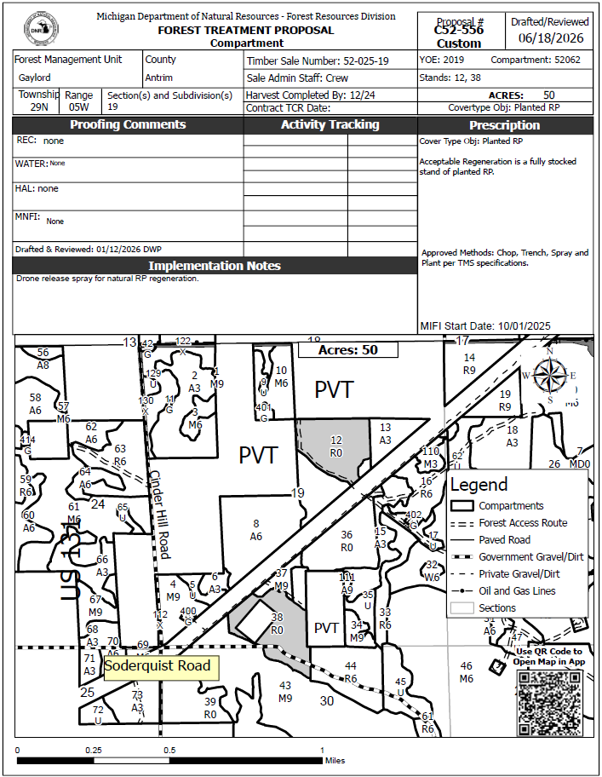
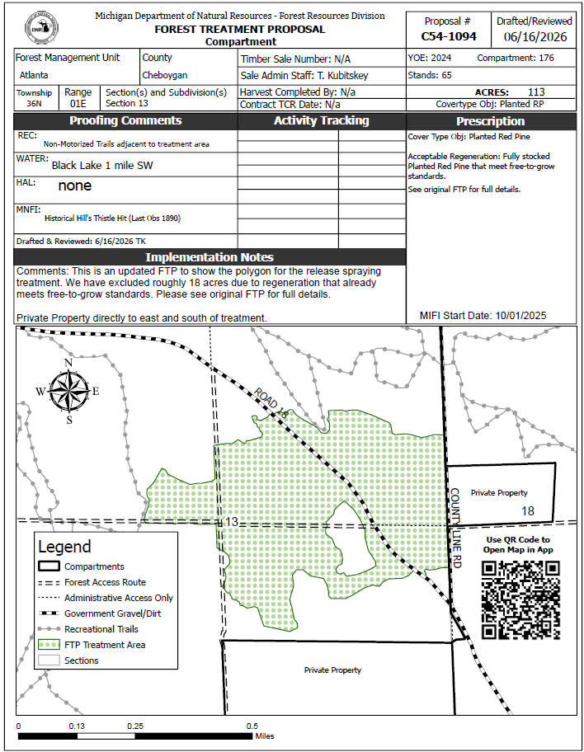

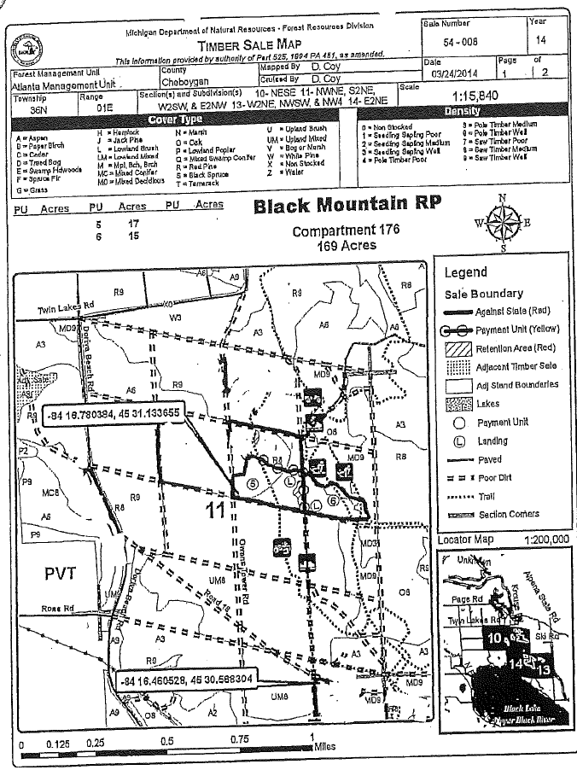

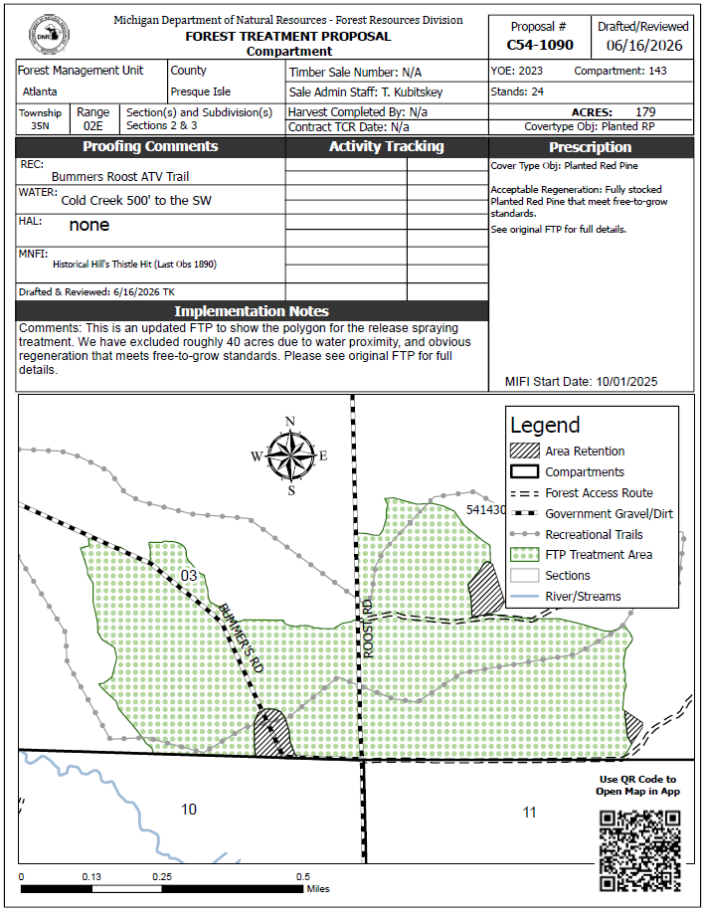

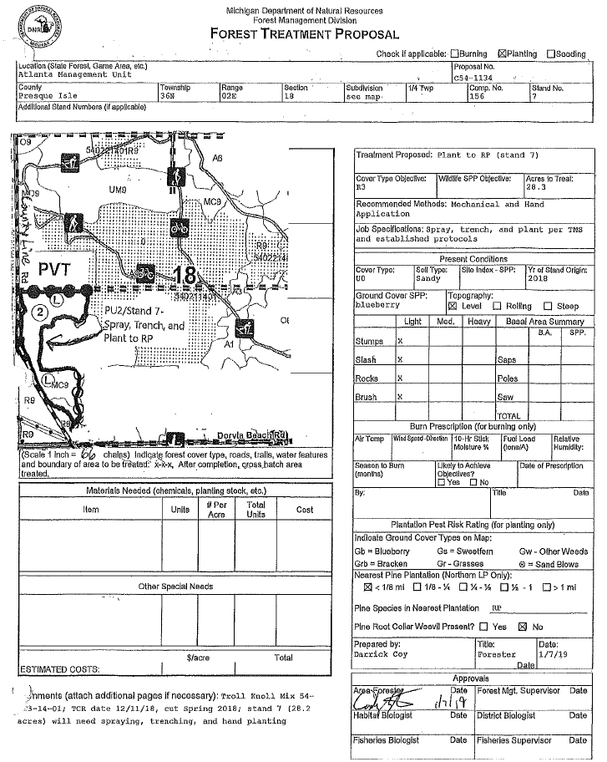

EASTERN UPPER PENINSULA
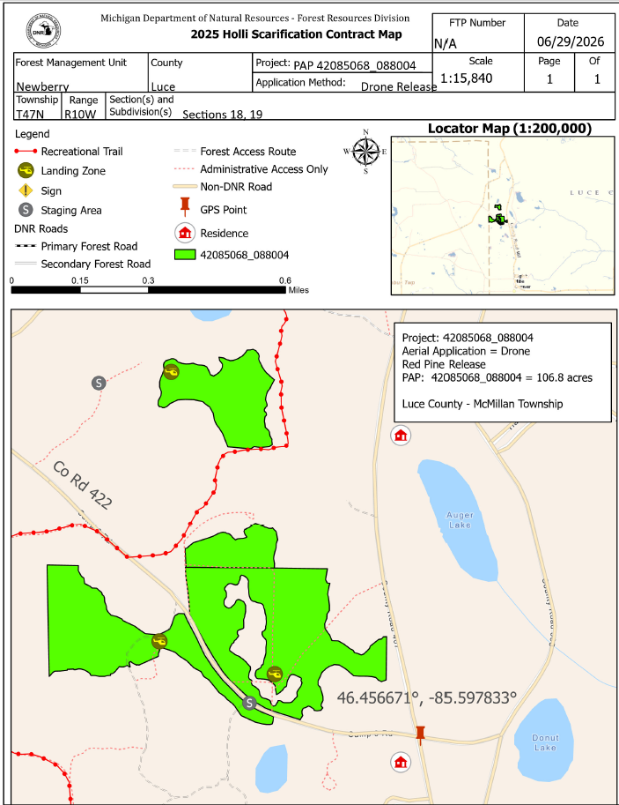
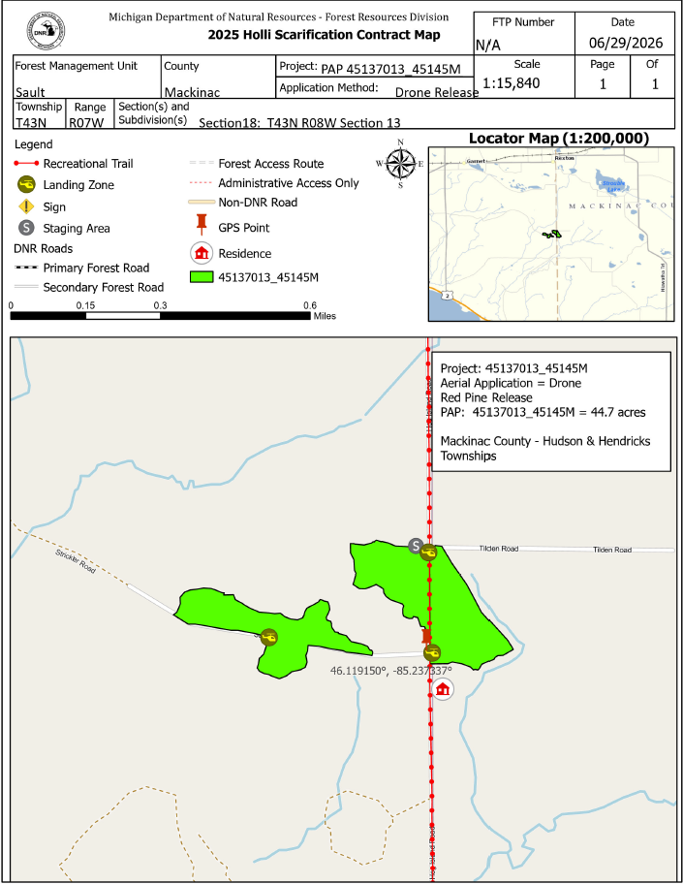

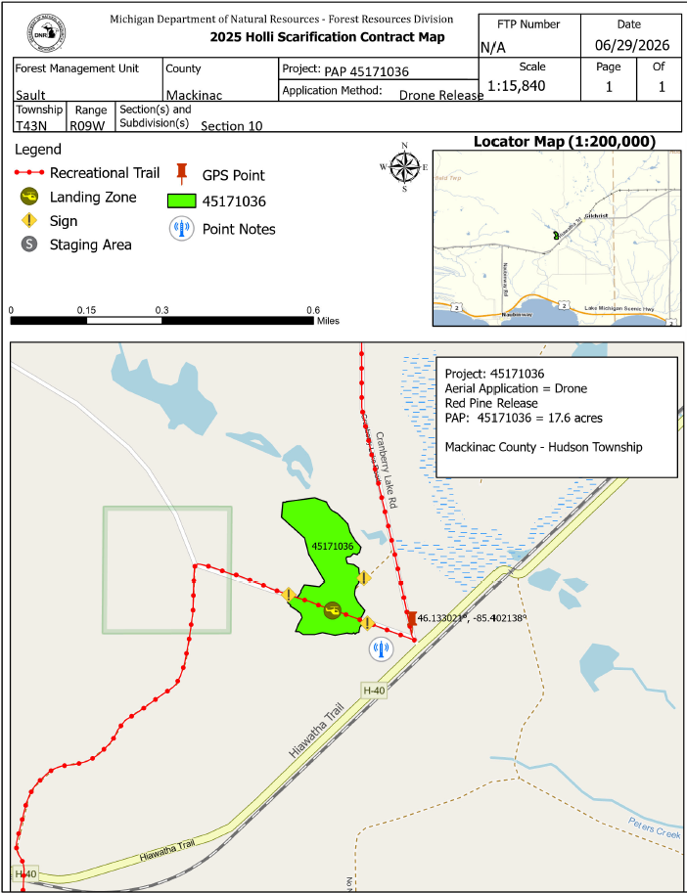

WESTERN UPPER PENINSULA
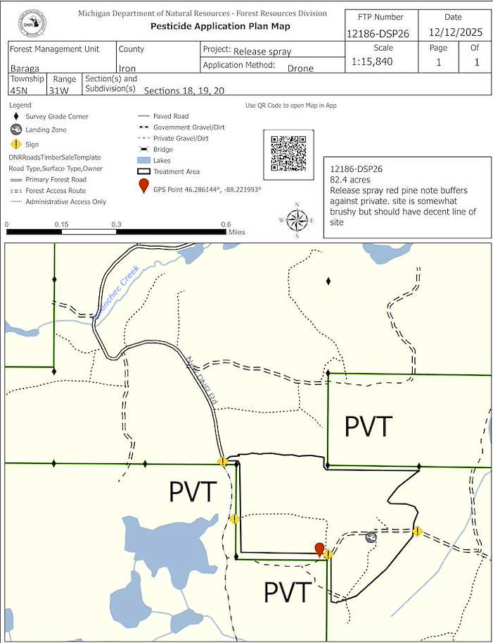

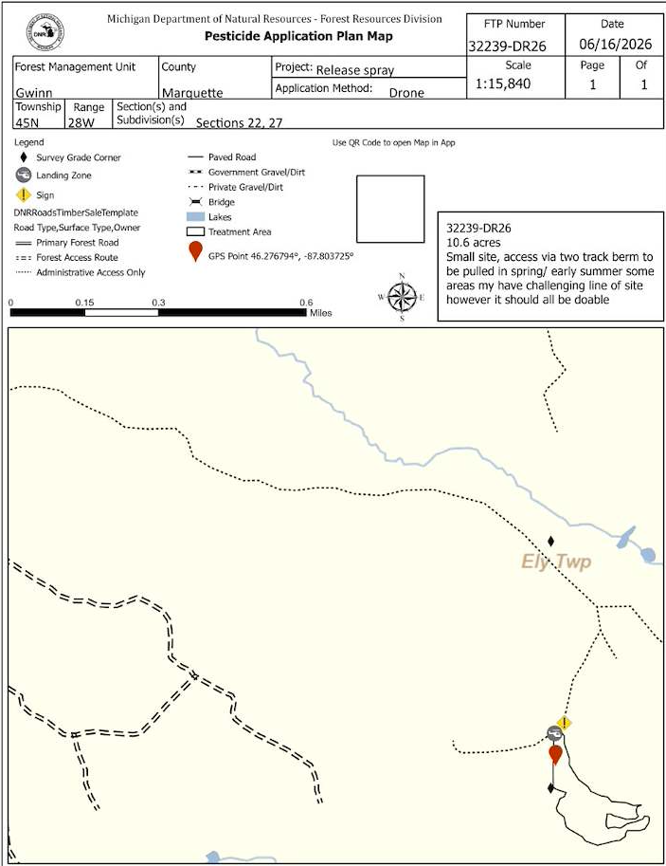

Schedule B – Pricing
Request for Proposal No. 260000002336
NR FRD Drone Aerial Release Spray FY26
- The Contractor must provide a pricing schedule for the proposed Contract Activities using the pricing spreadsheet provided Schedule B – Exhibit 1 – Pricing Spreadsheet. The pricing schedule should be submitted in a modifiable format (e.g. Microsoft Word or Excel); however, you may also submit an additional pricing schedule in a non-modifiable format (e.g., PDF). Failure to complete the pricing schedule as requested may result in disqualification of your proposal.
- Price proposals must include all costs, including but not limited to, any one-time or set-up charges, fees, and potential costs that Contractor may charge the State (e.g., shipping and handling, per piece pricing, and palletizing). The winning bid will be determined by the value placed in the Project Total cell in Schedule B, and a bid must be included for each site.
- The Contractor is encouraged to offer quick payment terms. The number of days must not include processing time for payment to be received by the Contractor's financial institution.
- Quick payment terms: Enter Percentage Amount% discount off invoice if paid within Enter Number of Days days after receipt of invoice.
- By submitting its proposal, the Contractor certifies that the prices were arrived at independently, and without consultation, communication, or agreement with any other Contractor.

PLEASE SEE PRICING Schedule B - Exhibit B

Schedule B – Exhibit B
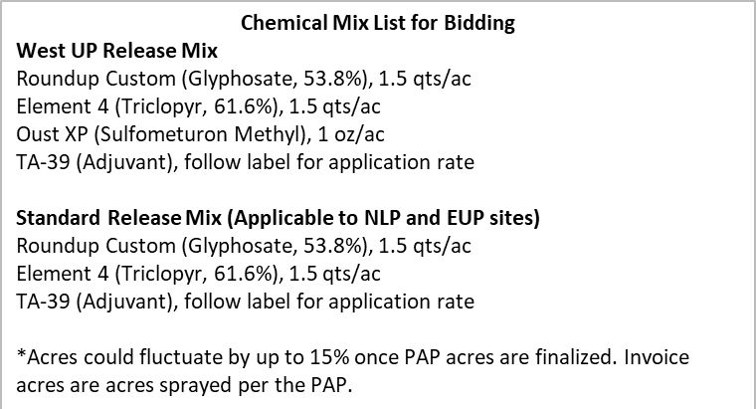
No alternative chemicals or mixes are permitted; you must use the chemicals and mixes that are approved

2026 Drone Release Bid Prices
Treatment Name | Location | Mix | Acres* | Per Acre Bid Price | Site Bid Price
52062038 | NLP | Standard | 24.2
52062012 | NLP | Standard | 25.8
54143024 | NLP | Standard | 179.6
54176065 | NLP | Standard | 113.4
54176017 | NLP | Standard | 25.9
54156007 | NLP | Standard | 24.2
42085068 | EUP | Standard | 29.2
42088004 | EUP | Standard | 77.6
45137013 | EUP | Standard | 14.6
45145124 | EUP | Standard | 17.3
45145138 | EUP | Standard | 10.8
45171036 | EUP | Standard | 17.6
12186008  (12186-DSP26) | WUP | West UP | 82.4
32239019  (32239-DR26) | WUP | West UP | 10.6
 |  |  |  | Project Total:

Schedule C – Insurance Requirements
NR FRD Drone Aerial Release Spray FY26
- General Requirements
  - Contractor, at its sole expense, must maintain the insurance coverage as specified herein for the duration of the Term. Minimum limits may be satisfied by any combination of primary liability, umbrella or excess liability, and self-insurance coverage. To the extent damages are covered by any required insurance, Contractor waives all rights against the State for such damages. Failure to maintain required insurance does not limit this waiver.
- Qualification of Insurers
  - Except for self-insured coverage, all policies must be written by an insurer with an A.M. Best rating of A- VII or higher unless otherwise approved by DTMB Enterprise Risk Management.
- Primary and Non-Contributory Coverage
  - All policies for which the State of Michigan is required to be named as an additional insured must be on a primary and non-contributory basis.
- Claims-Made Coverage
  - If any required policies provide claims-made coverage, Contractor must:
  - Maintain coverage and provide evidence of coverage for at least 3 years after the later of the expiration or termination of the Contract or the completion of all its duties under the Contract;
  - Purchase extended reporting coverage for a minimum of 3 years after completion of work if coverage is cancelled or not renewed, and not replaced with another claims-made policy form with a retroactive date prior to the Effective Date of this Contract.
- Proof of Insurance.
  - Insurance certificates showing evidence of coverage as required herein must be submitted to DTMB-RiskManagement@michigan.gov within 10 business days of the contract execution date.
  - Renewal insurance certificates must be provided on annual basis or as otherwise commensurate with the effective dates of coverage for any insurance required herein.
  - Insurance certificates must be in the form of a standard ACORD Insurance Certificate unless otherwise approved by DTMB Enterprise Risk Management.
  - All insurance certificates must clearly identify the Contract Number (e.g., notated under the Description of Operations on an ACORD form).
  - The State may require additional proofs of insurance or solvency, including but not limited to policy declarations, policy endorsements, policy schedules, self-insured certification or authorization, and audited financial statements.
  - In the event any required coverage is cancelled or not renewed, Contractor must provide written notice to DTMB Enterprise Risk Management no later than 5 business days following such cancellation or nonrenewal.
- Subcontractors.
  - Contractor is responsible for ensuring its subcontractors, if any, carry and maintain insurance coverage as applicable to the subcontracted service(s).
- Limits of Coverage & Specific Endorsements.

- Commercial General Liability Insurance
- Required Limits | - Additional Requirements
- Minimum Limits:  - $1,000,000 Each Occurrence  - $1,000,000 Personal & Advertising Injury  - $2,000,000 Products/Completed Operations  - $2,000,000 General Aggregate  - Deductible Maximum:  - $50,000 Each Occurrence | - Contractor must have their policy endorsed to add “the State of Michigan, its departments, divisions, agencies, offices, commissions, officers, employees, and agents” as additional insureds using endorsement CG 20 10 11 85, or both CG 20 10 12 19 and CG 20 37 12 19.
- Automobile Liability Insurance
- Required Limits | - Additional Requirements
- Minimum Limits:  - $1,000,000 Per Accident | - Contractor must have their policy: (1) endorsed to add “the State of Michigan, its departments, divisions, agencies, offices, commissions, officers, employees, and agents” as additional insureds; and (2) include Hired and Non-Owned Automobile coverage.
- Workers Compensation Insurance
- Required Limits | - Additional Requirements
- Minimum Limits:  - Coverage according to applicable laws governing work activities. | - Waiver of subrogation, except where waiver is prohibited by law.
- Employers Liability Insurance
- Required Limits | - Additional Requirements
- Minimum Limits:
- $500,000 Each Accident
- $500,000 Each Employee by Disease
- $500,000 Aggregate Disease

  - Chemical Liability Insurance
- Required Limits | - Additional Requirements
- Minimum Limits:  - $300,000.Per Occurrence  - $300,000 Aggregate | - Contractor must have their policy cover liability incurred out of the aerial application of seeds, fertilizers, or chemicals.

  - Aviation (Aircraft) Liability Insurance
- Required Limits | - Additional Requirements
- Minimum Limits:  - $1,000,000 Per Occurrence  - $2,000,000 Aggregate | - Contractor must have their policy cover products and completed operations, property damage, and bodily injury.

- Notice of Non-Compliance.
  - Contractor consents to receiving electronic communications from a third-party service provider, Origami Risk, for the exclusive purpose of notifying Contractor of non-compliance with the requirements set forth in this Schedule C.
- Non-Waiver.
  - This Schedule C is not intended to and is not to be construed in any manner as waiving, restricting or limiting the liability of either party for any obligations under this Contract, including any provisions hereof requiring Contractor to indemnify, defend and hold harmless the State.

